JOSÉ RIZAL UNIVERSITY

College Division

HealthBase: Patient Management, Smart Scheduling, and Return Visit Risk Prediction for Dr. Leelin Medical Clinic

A Project Study Presented to the Faculty of the
College of Computer Studies and Engineering

In Partial Fulfillment of the Requirements
for the Degree of Bachelor of Science in Information Technology

by

Morales, Vince Gabrielle B. Miranda, John Mar J. Ramos, Cheiszer R. Pineda, Shawn Marty R.

2nd Semester, SY 2024-2025

JOSÉ RIZAL UNIVERSITY
College Division

APPROVAL SHEET

The thesis, entitled HealthBase: Patient Management, Smart Scheduling, and Return Visit Risk Prediction for Dr. Leelin Medical Clinic prepared and submitted by VINCE GABRIELLE MORALES, JOHN MAR MIRANDA CHEISZER RAMOS and SHAWN MARTY PINEDA, in partial
fulfillment of the requirements for the degree of Bachelor of Science in Information Technology has been examined and recommended for acceptance and approval for Oral Presentation

VIRGINA B. LOYOLA, MIT
Research Adviser

Approved by the PANEL OF EXAMINERS on Oral Defense on with a grade of .

(name)
Chair

(name (name)
Member Member

SHARMAINE JUSTYNE R. MAGLAPUZ, DIT
Department Chair, Information Technology

Accepted and approved in partial fulfillment of the requirements for the degree of Bachelor of Science in Information Technology.

LIZA R. REYES, MENGG-CPE
Dean, Computer Studies and Engineering

JOSÉ RIZAL UNIVERSITY
College Division

CERTIFICATE OF ORIGINALITY

We hereby declare that the thesis entitled, HealthBase: Patient Management, Smart Scheduling, and Return Visit Risk Prediction for Dr. Leelin Medical Clinic is our own original work carried out as Bachelor’s student at José Rizal University except to the extent that assistance from others in the thesis’ design and conception or in style, presentation and linguistic expression are duly acknowledged.

All sources used for the thesis have been fully and properly cited. It contains no material which to a substantial extent has been accepted for the award of any other degree at JRU or any other educational institution, except where due acknowledgement is made in the thesis.

Signature Signature

VINCE GABRIELLE MORALES B, JOHN MAR MIRANDA J.

Signature Signature

CHEISZER RAMOS R. SHAWN MARTY PINEDA R.

ABSTRACT

Title : HEALTHBASE: PATIENT MANAGEMENT, SMART SCHEDULING AND RETURN VISIT RISK PREDICTION FOR
Dr. Leelin Medical Clinic No. of Pages :
Researchers : VINCE GABRIELLE MORALES JOHN MAR MIRANDA CHEISZER RAMOS

SHAWN MARTY PINEDA

Adviser : VIRGINIA B. LOYLA, MIT

School : José Rizal University
School Year : 2024-2025
Degree : Bachelor of Science in Information Technology

This study presents the development of HealthBase, a web-based clinical information system created for Dr. Leelin Medical Clinic, a private outpatient facility. HealthBase is designed to support outpatient healthcare providers in delivering faster, safer, and more coordinated care. By addressing key inefficiencies in patient flow and information handling, it empowers clinics to transition from manual processes to intelligent, data-driven operations. The system aims to improve clinical operations by automating patient management, enhancing health data handling, and streamlining administrative tasks. Built on user-centered design, HealthBase enables secure access to patient records, real-time health monitoring, and analytics-driven decision support. A core feature is its predictive module, which applies machine learning to identify patients at risk of return visits due to recurring conditions, allowing for proactive follow-ups. Hosted on both cloud and local servers, it ensures data security, redundancy, and role-based access. Grounded in Health Information Systems and Sociotechnical Systems theories, HealthBase illustrates how thoughtful integration of technology with clinical workflows can improve efficiency, continuity of care, and decision-making in a modern outpatient setting.
Keywords:

Health information system, patient management, clinic operations, return visit risk prediction, predictive analytics, machine learning, system integration, data security, role-based access, outpatient care technology, Leelin Medical Clinic, ISO 25010 Standards

TABLE OF CONTENTS

Title Page | …………………………… | i
Approval Sheet | …………………………… | ii
Certificate of Originality | …………………………… | iii
Abstract | …………………………… | iv
Table of Contents | …………………………… | vi
List of Figures
Figure 1.1. Conceptual Framework of
the Proposed Study | …………………………… | 14
Figure 3.1. Scrum Methodology Life
Cycle | …………………………… | 54
Figure 3.2. Data Analysis Process | …………………………… | 58
Figure 3.3. Context-Level Diagram of
the Proposed System | …………………………… | 60
Figure 3.4. Top-Level Diagram of the
Proposed System | …………………………… | 62
Figure 3.5. Child Diagram of Add and
Manage Patient Records of the
Proposed System | …………………………… | 64
Figure 3.6. Child Diagram of Manage
Clinic Metrics of the Proposed System | …………………………… | 65
Figure 3.7. Child Diagram of
Generate Reports and Dashboards of
the Proposed System | …………………………… | 66
Figure 3.8. Child Diagram of Update
Medical History of the Proposed | …………………………… | 67
System
Figure 3.9. Child Diagram of Update
Health Data of the Proposed System | …………………………… | 68
Figure 3.10. Child Diagram of Update
Patient Records of the Proposed
System | …………………………… | 69
Figure 3.11. Child Diagram of Patient
Data Requests of the Proposed | …………………………… | 70
System
Figure 3.12. Entity Relationship
Diagram of the Proposed System | …………………………… | 71
Figure 3.13. System Architecture of
the Proposed System | …………………………… | 73
Figure 3.14. Use-Case Diagram of
the Proposed System | …………………………… | 75

Chapter 1 INTRODUCTION | …………………………… | 8
Background of the Study | …………………………… | 8
Statement of the Objectives | …………………………… | 12
General Objectives | …………………………… | 12
Specific Objectives | …………………………… | 13
Conceptual Framework | …………………………… | 14
Significance of the Study | …………………………… | 15
Scope and Limitations | …………………………… | 17
Definition of Terms | …………………………… | 19
Chapter 2 REVIEW OF RELATED LITERATURE AND STUDIES | …………………………… | 21
Related Literature and Studies | …………………………… | 21
Relevance of Related Literature and Studies to the Current Study | …………………………… | 34
Chapter 3 METHODOLOGY | …………………………… | 51
Research Design | …………………………… | 51
Software Development Methodology | …………………………… | 52
Data-Flow Diagram | …………………………… | 60
Entity Relationship Diagram | …………………………… | 71
System Architecture | …………………………… | 73
Use-Case Diagram | …………………………… | 75
Research Locale | …………………………… | 76
Sources of Data | …………………………… | 77
Data Collection | …………………………… | 78
Instruments | …………………………… | 79
References | …………………………… | 81

Chapter 1 INTRODUCTION

Background of the Study

Healthcare information systems have evolved dramatically over the past few decades, shifting from paper-based records to integrated digital platforms that support various aspects of patient care [1]. In response to these advancements, HealthBase was developed for Dr. Leelin Medical Clinic, a modern private outpatient facility, to improve the efficiency and accuracy of patient management, appointment handling, and clinical decision-making. By moving away from manual paperwork, the clinic can digitally register patients, access medical histories, and manage consultations more effectively. HealthBase’s smart scheduling functionality helps minimize patient wait times and allows staff to efficiently manage their daily workload. It also uses machine learning to assess patients who may be at risk of returning due to ongoing or unresolved health conditions. This allows clinicians to deliver proactive care that improves patient outcomes and reduces workflow disruptions. With visual dashboards and simplified reports, clinic administrators gain better oversight of operational performance, resource allocation, and care quality. This transition from manual to intelligent, data-driven tools represents a key shift in outpatient healthcare. For clinics like Dr. Leelin Medical Clinic, where streamlined service and personalized care are essential, a secure and scalable information system like HealthBase can enhance safety, improve coordination, and simplify internal processes while protecting sensitive data [2]. The system transforms data management from basic recordkeeping into

a tool that enhances clinical accuracy, operational performance, and informed care planning, supported by visual summaries and performance tracking. Like many clinics, Dr. Leelin Medical Clinic faces limitations such as scattered patient records, manual health calculations, and time-consuming documentation. These outdated processes can lead to human error and inefficiencies in care workflows. By introducing an automated system, HealthBase directly addresses these pain points and reduces the risks associated with manual data handling [3]. Recent studies confirm that healthcare information systems have significantly advanced since the COVID-19 pandemic, leading to faster digital adoption across both hospital and outpatient settings [4]. HealthBase reflects this progress by incorporating modern database architecture that supports clinic needs. Electronic Health Records (EHRs) are now central to patient care, enabling structured data entry and better care coordination [5]. This level of digital centralization is critical for generating useful reports and supporting timely decision-making. HealthBase leverages current database technologies that balance security and accessibility for clinical users. Its modular design allows clinics to scale system features based on their resources, while custom algorithms enhance the accuracy of medical calculations [6]. Despite these advantages, smaller healthcare facilities often face challenges with limited IT staffing and technical capacity. Implementing HealthBase in such contexts can provide a much-needed solution to these constraints [4]. As healthcare systems become increasingly data-driven, the ability to turn patient data into actionable insights through analytics and visualization tools becomes highly valuable [7]. Evidence shows that clinical decision support

systems, when paired with well-designed alert features, can significantly reduce medication errors and improve care outcomes [8]. A well-structured Database Management System (DBMS) includes vital components such as secure data storage, query handling, and standardized data entry interfaces [9]. These systems form the backbone of medical data operations and support compliance with regulatory requirements [10]. The evolution of DBMS in healthcare has shifted from simple file-based models to relational and even NoSQL structures, which can manage large volumes and varied formats of medical information [1]. Modern systems often integrate cloud computing and distributed architecture to boost scalability and performance. Improvements in data analytics have also strengthened big data management in clinical environments [11]. Standards like HL7 and FHIR now guide healthcare system interoperability, allowing HealthBase to exchange data efficiently with external systems [12], [13]. Implementing HealthBase at Dr. Leelin Medical Clinic offers transformative potential to enhance care quality, accuracy, and efficiency. By supporting tailored calculations and structured analytics, the system fills key gaps in outpatient clinical operations. Through data visualization and predictive tools, HealthBase helps identify patients likely to return for follow-up, enabling staff to take early action and improve continuity of care [14]. Machine learning models that evaluate demographics, vitals, and prior visits are shown to be effective in this type of risk prediction [15]. By integrating these features into the system interface, HealthBase gives clinicians meaningful and timely insights to guide care delivery. Predictive scoring has become a valuable asset in many clinical systems, supporting early detection and

case prioritization [16]. By turning raw data into clear clinical intelligence, HealthBase empowers staff to act faster and more confidently. It also generates reports that support long-term quality improvement and reduce the burden of manual computation in day-to-day operations [4]. This approach is especially helpful in clinics managing increasing patient loads and limited staff, allowing them to maintain performance without sacrificing care quality. The system’s interface is built around user-centered design principles, which is a known factor in ensuring successful adoption of digital healthcare tools [16]. A strong user experience increases staff engagement and ensures the system is used consistently and effectively in real practice. By aligning interface design with clinical workflows and user habits, HealthBase offers a smooth and effective solution to modern outpatient data challenges. For Dr. Leelin Medical Clinic, it provides a reliable, intuitive platform that supports day-to-day operations, proactive care delivery, and long-term strategic growth..

Statement of the Objectives General Objective
To develop a clinical information system called HealthBase for Dr. Leelin Medical Clinic that enhances patient management, improves appointment scheduling, and predicts return visit risks by organizing patient records, tracking essential health data, streamlining follow-up care, and generating summarized reports to support clinical decision-making.

Specific Objectives

- To develop a patient management system that helps doctors make better decisions by organizing important health details, analyzing patient characteristics, and managing data efficiently.
  - Patient registration module with integrated patient profile data collection.

    - Basic Information

    - Health Concerns

    - Medical History

- To develop a Smart scheduling system that optimizes resource utilization while enhancing the patient experience through smart allocation algorithms.
  - Provider Availability System shows available doctors or

specialists and matches them with patients based on schedule and expertise.
  - Adaptive Patient Scheduling adjusts based on patient preferences, travel time, and urgency to ensure efficient and convenient appointments.

- To develop data visualization reports for predictive Return Visit risk.

  - Clinical Dashboards

  - Exportable reports in multiple formats

  - Integrate patient risk prediction models to identify individuals likely to require early return visits based on their clinical history and health data.
  - Display visual indicators for patients flagged as high-risk for return visits to support early intervention and follow-up planning.
- To evaluate the proposed system using the ISO standards ISO 25010- 2011/2023 in terms of:
  - Security

  - Reliability

  - Usability

  - Performance

  - Maintainability

Conceptual Framework
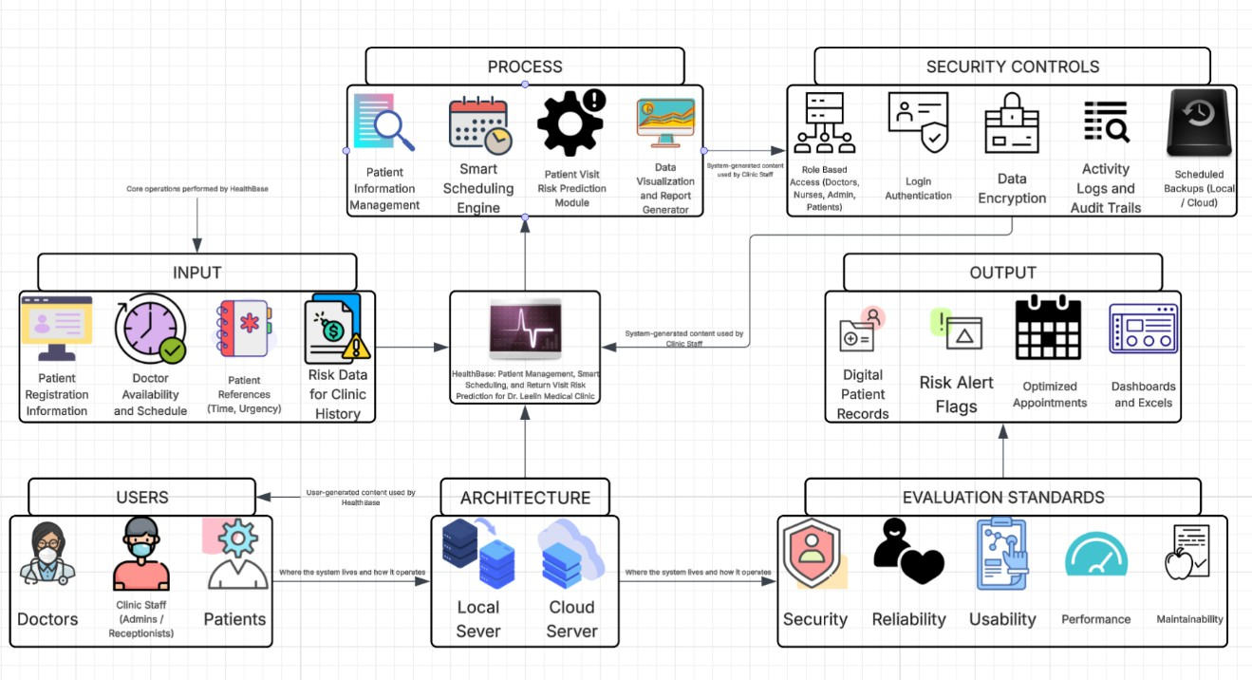
Figure 1.1 Conceptual Framework of the Proposed Study

This conceptual framework illustrates the structure and workflow of the HealthBase: Patient Management, Smart Scheduling, and Return Visit Risk Prediction system developed for Dr. Leelin Medical Clinic. It represents how patient care and clinic operations are enhanced through digital technology and predictive analytics. The framework begins by collecting patient details, doctor availability, scheduling preferences, and relevant clinical data. These inputs flow directly into integrated modules that securely manage patient information, intelligently schedule appointments, and proactively identify patients at risk of return visits. Additionally, HealthBase provides clear, visual reports and dashboards to support informed clinical and administrative decisions. Comprehensive security measures such as authentication, role-based access, encryption, and regular backups ensure data confidentiality and system reliability.

By integrating predictive analytics, HealthBase can anticipate potential patient health risks, enabling healthcare providers to take proactive steps in delivering patient care. This helps reduce unnecessary return visits, optimizes clinic resources, and enhances overall patient satisfaction. Moreover, the flexible hybrid architecture combining local and cloud-based systems ensures seamless scalability and reliable accessibility. It accommodates various user roles, allowing doctors and staff to manage patient care efficiently and enabling patients to actively participate in their own healthcare journey. Overall, the framework highlights HealthBase as a comprehensive, user-friendly solution that supports proactive decision-making, improved patient outcomes, and streamlined clinic operations for Dr. Leelin Medical Clinic.

Significance of the Study

The development of HealthBase: Patient Management, Smart Scheduling, and Return Visit Risk Prediction for Dr. Leelin Medical Clinic directly addresses the critical operational and clinical challenges encountered within outpatient healthcare settings. By integrating digital health technologies, Smart scheduling algorithms, and predictive analytics, this system enhances the efficiency of clinical workflows, improves the quality of patient care, and supports evidence-based clinical decision-making.
To the Patients. HealthBase will significantly enhance their healthcare experience by providing timely, coordinated, and personalized medical attention. Patients will benefit from shorter waiting periods, streamlined appointment

scheduling, and proactive care, especially for those identified as having a higher risk of return visits. This predictive feature ensures patients receive early interventions, contributing to improved health outcomes and greater satisfaction.
To Healthcare Professionals. Healthcare professionals at Dr. Leelin Medical Clinic will greatly benefit from HealthBase by having centralized and automated management of patient information. The system significantly reduces the time and effort required for manual documentation, enabling medical staff to focus more on patient interaction and quality care delivery. Additionally, integrated predictive analytics will help clinicians easily identify patients who may require extra attention, allowing for timely and precise clinical interventions to enhance patient safety and outcomes.
To Clinic Administration. Clinic administrators will find HealthBase’s structured visualization tools and comprehensive dashboards highly beneficial. These features provide timely and clear insights into patient trends, resource utilization, and overall clinic performance. The availability of easily interpretable reports supports informed decision-making, efficient resource management, and strategic operational planning, all while ensuring adherence to healthcare standards, including patient data privacy and security.
To Researchers. This study presents a valuable opportunity to explore the application of machine learning, data visualization, and patient-centered health system design in a real outpatient clinical environment. Through HealthBase at Dr. Leelin Medical Clinic, researchers can examine firsthand how predictive analytics

and user-focused interfaces contribute to improving clinical workflows, patient outcomes, and continuity of care.
To Future Researchers. This research project provides foundational knowledge and serves as a reference for future studies in healthcare informatics, particularly within private outpatient settings. Future research may build upon this work by extending predictive capabilities, exploring mobile or telehealth integrations, or adapting HealthBase to accommodate larger practices or multi- branch clinical networks.

Scope and Limitations

This study focuses on the design and implementation of HealthBase, a cloud-based clinical information system specifically developed for Dr. Leelin Medical Clinic, a private outpatient facility. HealthBase aims to digitize core clinical operations, including patient registration, health record management, smart scheduling, and return-visit risk prediction. The system ensures accurate, consistent, and easily accessible patient information, streamlining daily workflows for healthcare professionals and supporting clinical decision-making through

organized patient data and predictive analytics. Additionally, HealthBase incorporates automated medical calculation features to reduce manual documentation tasks and improve the accuracy of patient treatment planning. User-friendly visualization tools are integrated to simplify the interpretation of clinical data. To uphold patient confidentiality and comply with privacy standards, the system employs appropriate access control and secure data handling protocols.
However, the implementation scope of HealthBase is exclusively within Dr. Leelin Medical Clinic and does not extend to other healthcare providers or external healthcare networks. The system explicitly excludes financial management, billing transactions, and inventory management functionalities. While designed for cloud- based operations with potential future compatibility for data exchange, initial deployment will not include integration with external or third-party healthcare systems. The security measures incorporated in this study reflect standard privacy protection practices, and advanced cybersecurity features are not addressed within this research. Additionally, aspects such as comprehensive user training, onboarding processes, and long-term maintenance strategies fall outside the scope of this initial implementation.

Definition of Terms

HealthBase – A digital clinical system designed specifically for Dr. Leelin Medical Clinic to manage patient information, appointments, and health data efficiently..
Patient Management – The organized way of collecting, updating, and keeping track of patient information, making sure it's accurate and easy to access by clinic staff.
Smart Scheduling – A feature in HealthBase that automatically schedules patient appointments based on their specific needs and the availability of clinic doctors.
Return Visit Risk Prediction – A tool within HealthBase that predicts which patients might need to come back for additional care, helping doctors provide timely follow-ups.
Automated Medical Calculations – Built-in features of HealthBase that automatically calculate important medical data, reducing mistakes from manual computations and saving staff time.
Predictive Analytics – Using past patient information to predict possible future health needs or issues, helping clinic staff to proactively care for their patients.
Data Visualization Tools – Visual charts and reports within HealthBase that clearly display patient data and clinic performance, making it easier for staff to understand and use the information.

Access Control – Security features in HealthBase ensuring that only authorized people can view and manage patient information.
Data Privacy Compliance – Following established rules and standards to ensure patient information stays safe, secure, and confidential within the HealthBase system.
User-Centered Design – Designing HealthBase specifically around the needs and workflows of the clinic's staff and doctors, ensuring the system is easy and comfortable to use.
Cloud-Based System – A type of technology setup where HealthBase stores and manages data online, allowing secure access from anywhere via the internet.
Outpatient Care – Healthcare provided to patients who visit the clinic for consultations or treatments without staying overnight or being admitted to a hospital
.

Chapter 2

REVIEW OF RELATED LITERATURE

This chapter presents the relevant literature and studies that the researcher considered to strengthen the importance of the present study. It also presents the synthesis of the art to understand the research for a better comprehension of the study.

Patient Information Management Systems and EHR Evolution

The progressive evolution of Electronic Health Records (EHR) and Health Information Systems (HIS) has fundamentally transformed how healthcare facilities collect, organize, and utilize patient data. These systems have transitioned from simple repositories of patient demographics to comprehensive platforms that integrate medical histories, treatment plans, and clinical decisions across multidisciplinary teams. This shift reflects the global momentum toward digitizing health infrastructure to enhance patient safety, continuity of care, and operational efficiency. According to [53], a 25-year review of EHR systems illustrates how implementation has matured from basic digital archives to robust, interoperable systems capable of supporting population health analytics. The study emphasizes that successful EHR deployment is not merely a technical endeavor but one that relies on process alignment, leadership engagement, and adaptive implementation strategies. Similarly, [24] demonstrated that in Malaysian healthcare settings, the adoption of EHRs led to measurable improvements in clinical workflow, accuracy in documentation, and provider performance. These findings resonate with the needs of facilities like Dr. Leelin Medical Clinic, where

streamlined data access and care coordination are vital in an outpatient context. However, several studies highlight persistent challenges that undermine the full potential of EHRs. [26] and [30] note that although open-source EHRs offer cost- effective and customizable solutions, they frequently lack compliance with healthcare interoperability standards such as HL7 and FHIR. Additionally, these systems often underperform in environments with limited IT capacity, where training and support infrastructures are weak or inconsistent. [28] revealed that in the Philippine context, the user experience with EHR systems varies greatly depending on the availability of staff support, intuitive system design, and long- term usability planning. These challenges are compounded in resource-limited settings, where digital literacy remains low, and institutional resistance to technological change is prevalent. In addition to technical limitations, organizational and human factors play a decisive role. Studies like [41] emphasize that user satisfaction is closely tied to EHR usability, workflow alignment, and interface responsiveness. Without consistent training and involvement in system development, even the most advanced EHR systems risk underutilization or rejection. Meanwhile, [31] and [32] show that during health emergencies such as the COVID-19 pandemic, digital adoption surged but often declined post-crisis due to poor integration into routine operations and lack of sustainability measures. This suggests that successful long-term EHR deployment requires systems to be context-sensitive, modular, and supported by institutional change management strategies.

HealthBase builds on these insights by offering a localized, outpatient-focused solution designed for sustainable adoption in a private clinic setting. It integrates core EHR functionalities—such as structured patient data entry, secure health information access, and role-based permissions—within a flexible architecture that can be hosted on both cloud and local servers. In contrast to earlier systems criticized for lacking usability and integration ([26], [41]), HealthBase is developed using user-centered design principles to improve healthcare worker engagement and minimize resistance. Moreover, it anticipates future needs by embedding support for interoperability and advanced analytics, including return visit risk prediction.
In conclusion, the literature demonstrates that the evolution of EHRs and patient information systems is marked by significant gains in care delivery but tempered by usability, technical, and organizational barriers. The HealthBase project responds directly to these challenges, offering a scalable and intuitive system aligned with the unique operational realities of Dr. Leelin Medical Clinic. It reflects best practices from global research while addressing specific local needs, contributing to a more sustainable and effective approach to digital health transformation in outpatient care.

Smart Scheduling and Appointment Optimization

In recent years, healthcare institutions have increasingly turned to digital scheduling solutions to mitigate inefficiencies related to long wait times, uneven

appointment distribution, and suboptimal provider-patient alignment. Studies across outpatient settings highlight the transformative role of intelligent scheduling systems in improving resource utilization, reducing patient no-shows, and enhancing care continuity. These systems leverage real-time availability, predictive algorithms, and patient-preference data to dynamically assign appointments, thus aligning clinical demand with service capacity. [26] reviewed the most recent advances in open-source EHR platforms, many of which integrate patient scheduling modules designed to optimize appointment timing, minimize overlaps, and accommodate physician availability. While the systems show promise, they frequently lack adaptive capabilities that factor in urgency, historical attendance, and patient condition severity. [33] emphasized that successful digital scheduling hinges on interoperability, user engagement, and system responsiveness to changes in care demand. These findings align with [45], who identified scheduling friction as a major contributor to provider burnout, particularly in resource-limited and high-patient-load clinics. Further, [28] explored EMR adoption during the COVID-19 pandemic, noting that digital scheduling saw a spike in use but often failed to scale sustainably post-crisis due to lack of staff training and poor system usability. Studies like [41] and [39] found that while clinicians appreciated digital tools for managing appointments, many platforms lacked integration with clinical decision-making systems, resulting in redundant steps and workflow misalignment. In high-volume outpatient environments, [36] noted that smart scheduling systems with built-in triage, alerts, and visit prioritization significantly improve throughput and patient satisfaction.

Despite these gains, limitations persist. Many platforms do not personalize scheduling based on contextual data such as patient demographics, travel time, or likelihood of reappointment. Additionally, there remains a lack of integration between scheduling tools and patient risk data, which could otherwise enable preemptive booking for at-risk individuals. These gaps hinder the ability to provide targeted and proactive care, especially in settings with constrained manpower or fluctuating demand. HealthBase addresses these shortcomings by embedding an intelligent, patient-centered scheduling subsystem tailored for Dr. Leelin Medical Clinic. It includes adaptive patient matching based on urgency, patient preference, doctor availability, and travel considerations. Beyond routine appointments, it integrates with a return visit risk prediction module that flags high-risk patients for follow-up prioritization. This ensures that vulnerable individuals are scheduled earlier, enabling proactive interventions. HealthBase also simplifies workflows through an intuitive dashboard that visualizes booking metrics and workload distribution, aiding both clinical and administrative decision-making. Unlike traditional schedulers, it aligns clinical urgency with system recommendations, ensuring that smart scheduling is not just operational but also clinically meaningful.

Return Visit Risk Prediction and Clinical Decision Support

Return visits in outpatient settings are often linked to incomplete treatment, unresolved symptoms, or undetected comorbidities. Predictive analytics has become a crucial tool in identifying patients who may be at risk for unplanned return visits. A growing number of studies have explored how machine learning (ML)

models, when trained on structured EHR data, can generate risk scores that assist clinicians in prioritizing follow-up care. For example, [13] conducted a systematic review that emphasized the utility of EHR-based risk prediction models in accurately flagging patients with high readmission probability, showing that demographic variables, comorbidities, and prior visit patterns were strong predictors of return. Complementing this, [11] introduced a multi-output Gaussian process RNN capable of real-time validation for early sepsis detection, illustrating how temporal modeling can significantly enhance clinical decision-making. Although focused on inpatient contexts, the same principles apply to outpatient settings, especially where follow-up care is essential. Likewise, [15] highlighted the importance of leveraging unstructured EHR data for richer analysis, addressing gaps in current models that rely primarily on coded values. Their study found that inclusion of physician notes and patient narratives can boost predictive accuracy when integrated through natural language processing.
However, the deployment of such predictive tools in smaller or private outpatient clinics remains limited due to infrastructure constraints, data quality concerns, and lack of trained personnel. [18] emphasized that data quality assessments are rarely automated, making it difficult to sustain reliable ML-driven insights over time. In the Philippine context, [20] revealed that while clinicians are open to predictive technology, interoperability and integration with current health systems remain persistent challenges. The review concluded that predictive tools often lack localized data sets and clinical pathways, making it harder for healthcare staff to trust or act on generated risk scores. Addressing these challenges, the

HealthBase system integrates a dedicated return visit risk prediction module designed for outpatient environments like Dr. Leelin Medical Clinic. The system applies machine learning models to structured health data such as visit frequency, vitals, and diagnosis history to generate personalized return risk scores. By highlighting high-risk patients directly within the smart scheduling interface, HealthBase empowers healthcare providers to proactively intervene and prioritize follow-up visits. Furthermore, HealthBase features customizable clinical dashboards that visualize predicted risks in real time and facilitate data-driven planning. These innovations not only reduce the burden of manual flagging but also align with the broader goal of predictive, preventive, and personalized medicine. Through a practical and scalable implementation of clinical decision support, HealthBase enhances continuity of care and supports better patient outcomes in resource-constrained outpatient settings.

Smart Scheduling and Patient Flow Optimization in Outpatient Settings

Efficient scheduling systems are central to outpatient service delivery, influencing both clinical efficiency and patient satisfaction. Traditional appointment systems often fail to consider variables such as urgency, provider availability, patient preferences, and expected consultation durations—leading to bottlenecks, extended waiting times, and resource underutilization. Literature over the past

decade has increasingly highlighted the potential of intelligent scheduling tools to transform outpatient operations. For instance, [2] emphasized that big data techniques can be used to dynamically adjust appointment systems in real-time, optimizing patient flow and reducing idle time for providers. These technologies enable adaptive scheduling based on patient histories, risk categories, and predictive metrics. Furthermore, [17] identified implementation considerations for deploying digital health tools in large systems, stressing that smart scheduling features require integration with EHRs, staff workflows, and patient communication channels to be effective. [8] also demonstrated the potential of analytics to anticipate patient demand patterns, especially when paired with historical appointment data, enabling proactive resource planning. Despite these benefits, several challenges persist. [38] found that organizational readiness, user resistance, and lack of training often delay the adoption of smart scheduling systems in developing countries. In many cases, existing hospital scheduling systems are static and lack decision-support mechanisms. [33] reported that users frequently experience frustration due to rigid appointment structures, especially when patient needs vary widely. The study pointed to poor interface design and lack of real-time flexibility as common limitations.
The Philippine context, as discussed in [22] and [35], illustrates that even during the COVID-19 pandemic, many outpatient clinics continued to rely on manual or semi-digital scheduling methods, leading to missed appointments and underutilized time slots. These gaps demonstrate the need for patient-centered, adaptive scheduling approaches that are aligned with actual clinical workflows. In

response, the HealthBase system integrates a Smart Scheduling Module designed to optimize outpatient care delivery for Dr. Leelin Medical Clinic. This module incorporates adaptive appointment allocation, which considers patient urgency, doctor availability, clinic capacity, and predicted return risks. The system allows patients to be automatically matched with the appropriate provider based on health concern categories and time sensitivity. Additionally, HealthBase accommodates dynamic adjustments, such as rescheduling based on real-time provider availability or patient cancellations, enhancing scheduling flexibility and reducing no-show rates. The integration of patient flow analytics also enables clinic administrators to monitor peak hours, allocate resources effectively, and improve the overall continuity of care. Through intelligent scheduling, HealthBase not only reduces wait times and overcrowding but also improves clinical efficiency and patient experience in a busy outpatient environment.

Health Data Visualization and Decision Support Systems

In modern outpatient healthcare environments, the ability to transform raw data into actionable insights is essential for enhancing clinical decision-making, resource planning, and operational oversight. Decision Support Systems (DSS), especially those integrated with Electronic Health Records (EHRs), play a critical role in identifying patient risks, improving diagnostic accuracy, and ensuring timely interventions. Visualization tools—such as clinical dashboards and exportable summary reports—are now considered indispensable features of advanced Health Information Systems (HIS). [5] conducted a systematic review and confirmed that

Clinical Decision Support Systems (CDSS) can significantly improve medication safety, reduce adverse events, and enhance diagnostic precision when properly integrated with existing workflows. These systems are most effective when paired with clear visual indicators and alerts, which simplify data interpretation for clinicians. Similarly, [7] emphasized that a strong Database Management System (DBMS) backbone is necessary for real-time data handling and visualization, allowing users to view trends and metrics with minimal latency. Yet, studies such as [47] and [18] noted that data quality and completeness remain persistent issues. Poorly structured inputs, fragmented information sources, and inconsistent data entry protocols hinder the effectiveness of DSS and visual analytics. [54] underscored that even in systems with advanced alerts and dashboards, if the underlying data is inaccurate or delayed, decision-making can be compromised. Another key barrier to effective data visualization tools is the lack of training or standardized usage among healthcare personnel, as highlighted in [36]. Moreover, in resource-limited settings like many private clinics in the Philippines, implementation of real-time decision support is often constrained by hardware limitations, internet reliability, and the absence of localized predictive models. [42] found that healthcare workers often rely on basic reporting tools rather than advanced analytics, limiting the value of collected data. [51] also emphasized the need for dashboard customization and user-focused design in ensuring adoption and utility in clinical environments.
To address these gaps, the HealthBase system developed for Dr. Leelin Medical Clinic integrates a robust data visualization module designed to support

predictive analytics and facilitate rapid clinical insight. The system features interactive dashboards that track patient demographics, visit frequencies, risk scores, and provider workloads. Exportable reports in various formats support both day-to-day management and periodic performance reviews. A key innovation is the predictive decision support tool embedded within the interface, which utilizes patient histories, vital signs, and risk factors to flag individuals at risk for early return visits. This feature empowers providers to plan proactive care and follow-up strategies. Furthermore, the system’s visual indicators—such as color-coded alerts and severity labels—enhance usability and reduce cognitive load, making it easier for clinicians to prioritize patient needs. Through these tools, HealthBase enhances the clinic’s capacity for informed, data-driven, and timely decision- making, while ensuring that critical information is presented in a manner that supports clinical efficiency and continuity of care.

Synthesis

The collective body of related literature highlights that successful implementation of Electronic Health Records (EHRs) and Health Information Systems (HIS) requires more than just advanced technology—it demands a holistic strategy that integrates user-centered design, institutional readiness, continuous user training, and strategic policy support. While structured digital systems promise improved data accuracy, reduced clinical errors, and enhanced service coordination, these benefits are often compromised by fragmented system integration, limited digital literacy, and inconsistent organizational commitment. Case studies and longitudinal reviews stress that long-term sustainability depends

on supportive leadership, standardized data entry, stakeholder engagement, and a robust evaluation framework.
Key studies also draw attention to persistent challenges in data quality, interoperability, and system usability. Open-source systems and proprietary platforms alike struggle with underdeveloped user interfaces, limited analytics capabilities, and inadequate customization for low-resource or outpatient contexts. Moreover, cybersecurity concerns, insufficient technical infrastructure, and resistance to workflow changes further hinder system effectiveness—particularly in resource-constrained healthcare environments. Addressing these issues requires adaptable systems that balance technical sophistication with accessibility and organizational fit. The evolution of clinical decision support systems (CDSS) and smart scheduling tools reveals a growing focus on predictive analytics, risk stratification, and personalized care. Literature confirms that AI-enhanced scheduling and return visit risk models can optimize patient flow and improve resource allocation. However, their practical adoption is constrained by lack of real- time integration, minimal validation in real-world settings, and challenges in aligning algorithms with actual provider routines and patient preferences. Risk models must also integrate both structured and unstructured health data, including social determinants of health, while remaining transparent, secure, and scalable. In addition, studies affirm that well-designed dashboards, descriptive analytics, and automated report generators play a vital role in turning complex patient data into actionable insights for clinical and administrative use. However, the success of these tools hinges on interoperability standards (e.g., HL7, FHIR), real-time data

accuracy, user training, and alignment with the clinical workflow. Without these elements, decision support tools risk underutilization or user fatigue. In direct response to these multidimensional challenges and insights, HealthBase was designed as a secure, modular, and intelligent clinical information system tailored for the outpatient environment of Dr. Leelin Medical Clinic. Its subsystems address the core needs identified in the literature: patient information management, intelligent scheduling, real-time data visualization, and risk-aware predictive analytics. By embedding role-based access controls, machine learning models for return visit risk, adaptive appointment modules, and exportable reporting dashboards, HealthBase bridges the gap between academic research and practical system application. It aligns with evidence-based design principles by focusing on usability, modular scalability, and data-driven decision-making. Ultimately, HealthBase embodies a human-centered, analytics-supported approach to digital healthcare transformation. It addresses identified literature gaps such as weak interoperability, inconsistent EHR adoption, and limited use of predictive modeling in outpatient clinics. The system offers a forward-looking, evidence-informed solution that enhances clinical workflows, strengthens data governance, and supports early interventions—thus positioning itself as a replicable and sustainable model for other outpatient healthcare settings seeking to transition into intelligent, digitally mature operations.

Relevance of Related Literature to the Current Study
Table 2.1 Comparisons/Differences of Previous and Present Study

Title | Author( s) | Date | Key Findings | Key Gaps | Present Study
Evaluating the effects of electronic health records system adoption on the performanc e of Malaysian healthcare providers | M. I. M.  Salleh, R.  Abdulla h, and N.  Zakaria | June 30,  202  1 | The adoption of EHR systems at Dr. Leelin Medical Clinic improved healthcare provider performance by increasing data accuracy, enhancing care efficiency, and strengthening communicatio n among medical staff. The study also showed improved clinical decision- making and optimized workflow due to EHR integration. | While the study emphasizes general performance improvement from EHR use, it lacks focus on advanced features such as intelligent scheduling and predictive risk tools, which are essential for optimizing follow-up care and resource allocation. | The current study (HealthBase) builds on these findings by integrating patient management with smart scheduling and readmission risk prediction— features not covered in the previous study. It is designed specifically for clinics like Dr. Leelin Medical Clinic to improve clinical outcomes, streamline processes, and maximize the benefits of digital health systems.

25 years of electronic health record implementa tion processes: Scoping review.  Journal of Medical Internet Research | H.  Finnega n and N. Mountfo rd | Mar ch 3,  202  5 | This scoping review explores the 25-year evolution of Electronic Health Records (EHRs),  showing how they have developed from basic data repositories into core tools for healthcare delivery. It highlights the importance of implementatio n processes for maximizing the benefits of EHRs,  particularly in improving efficiency and patient care. | Despite progress, implementatio n challenges remain— especially in areas such as system interoperability  , standardized procedures, and user engagement. These gaps prevent full optimization of EHRs in clinical settings like Dr. Leelin Medical Clinic. | The HealthBase project responds to these gaps by introducing a comprehensiv e, clinic- specific patient management system. It focuses on intelligent scheduling, readmission risk prediction, and user- friendly design. By prioritizing interoperability and usability, HealthBase aims to overcome existing implementatio n barriers and enhance both workflow efficiency and patient outcomes at Dr. Leelin Medical Clinic.
Open- source | M.  Shaikh, | April 1, | This review underscored | The study identified | HealthBase fills these

electronic health record systems: A systematic review of most recent advances | A. H. M.  Vayani, S.  Akram, and N. Qamar | 202  2 | the growing potential of open-source EHR platforms in offering flexible, cost- efficient healthcare data management solutions. It highlighted benefits such as customization, community- driven innovation, and alignment with open standards, as well as how some open- source platforms perform against HIMSS- EMRAM  stages. | major concerns in implementatio n, including lack of structured evaluation models, inconsistent compliance with healthcare standards, and variability in user and developer support. It also found that many open-source EHRs lacked advanced functionalities like predictive modeling and intelligent workflows. | gaps by being a standards- compliant, open-source clinical system that integrates essential features such as patient risk prediction and intelligent scheduling. It adheres to HIMSS- EMRAM  principles while focusing on improving care delivery and efficiency within outpatient settings.
Usability evaluation of electronic health records | Antor, E.,  Owusu- Marfo, J., &  Kissi, J. | 202  4 | This research focused on evaluating EHR usability and how interface design impacts | Although usability was the central theme, the study did not consider how poor usability might affect | HealthBase adopts a user- centered design framework tailored for outpatient clinic users,

 |  |  | system adoption. It concluded that user satisfaction and system efficiency are heavily influenced by intuitive design, fast navigation, and integration into routine workflows, especially in high-pressure clinical environments. | newer functions like smart scheduling or predictive modules. It also did not examine outpatient- specific design principles, which require lightweight and highly accessible systems for smaller clinics. | particularly physicians and administrators at Dr. Leelin Medical Clinic. Its UI/UX prioritizes intuitive navigation for patient management, integrated scheduling, and predictive insights— improving not only usability but also clinical responsivenes s and operational control.
Nurses’ satisfaction with adopting a homegrown public tertiary hospital electronic medical record during the pandemic | Rosales  , N. R. B. | 202  4 | This study evaluated user acceptance of a custom-built EMR system deployed in a public hospital during  COVID-19. It  highlighted that homegrown systems | The study focused on user satisfaction but did not delve deeply into how such systems could integrate advanced features like predictive analytics, nor did it offer | HealthBase builds on the notion of custom- tailored clinical systems by creating a solution specifically for Dr. Leelin Medical Clinic. It surpasses the prior

 |  |  | tailored to the unique needs of specific hospitals can significantly boost user satisfaction and operational relevance, especially when external solutions lack flexibility. | insights on their scalability or adaptability to outpatient environments. The model also lacked comparative performance analysis against commercial systems. | study’s scope by integrating data science for return visit prediction, performance monitoring, and smart scheduling, offering a scalable outpatient solution with modern analytical capabilities.
Hospital readmissio n risk prediction using EHR data: A systematic review | Holmgre n, L. et al. | 202  0 | This review provided evidence that EHR-based predictive models can effectively forecast hospital readmissions by analyzing patterns in demographics  , clinical history, comorbidities, and past admissions. It underscored the clinical value of early | While the review highlighted the potential of risk prediction, most models were hospital- based and lacked adaptability for outpatient use. Many studies focused on retrospective analytics with limited real- time applications or integration into | HealthBase brings these predictive capabilities into the outpatient context of Dr. Leelin Medical Clinic. It integrates a real-time return visit risk prediction module directly within the scheduling and patient management system— allowing staff to act

 |  |  | risk identification in reducing rehospitalizati on rates and improving healthcare planning. | operational workflows like patient scheduling or care planning. | proactively on high-risk patients during clinic visits and manage resources more effectively.
Facing the digital frontier: Exploring user acceptance of electronic health records in the Philippines | De Mesa,  R. Y. H.  et al. | 202  4 | This study emphasized the importance of perceived usefulness and ease of use in shaping healthcare professionals’ attitudes toward EHR systems in the Philippines.  Key findings revealed that systems that align well with clinical workflows and are designed with user feedback lead to higher acceptance and sustained usage. | Although the study provided critical sociotechnical insights, it focused mostly on user acceptance rather than on the technical capabilities of EHR systems like smart scheduling or predictive features. It also did not address how system adoption impacts long- term operational performance in outpatient settings. | HealthBase incorporates the principles of user- centered design and local context alignment to drive strong adoption at Dr. Leelin Medical Clinic. Going beyond EHR  acceptance, the system integrates intelligent features such as predictive risk scoring and automated reporting to demonstrate tangible improvements in outpatient service

 |  |  |  |  | delivery and user engagement.
Impact of patient access to their electronic health record: Systematic review | Tapuria,  A. et al. | 202  1 | This study confirmed that giving patients access to their EHRs  improves transparency, patient engagement, and adherence to treatment plans. It highlighted how patient portals and interactive systems can support shared decision- making and increase patient trust in healthcare services. | However, the review focused mainly on patient-facing features and did not explore backend systems or how healthcare providers can use patient data for analytics or decision- making.  Integration of patient access with predictive functions or smart scheduling was not addressed. | While HealthBase does not yet include direct patient access portals, it centralizes patient data in a way that enhances provider- patient communicatio n, allowing clinicians to generate visual summaries and risk assessments. Future updates may incorporate patient access, but the current version prioritizes provider-led engagement and decision- making.

Big data analytics in healthcare: Promise and potential | Zhang,  Y. et al. | 202  0 | This article discussed how big data technologies have transformed healthcare by enabling the extraction of meaningful insights from vast clinical datasets. It pointed out that predictive modeling, trend analysis, and real-time decision support are increasingly being adopted to improve patient outcomes and resource efficiency. | While highlighting opportunities, the article lacked concrete applications in outpatient settings and did not elaborate on implementatio n challenges for small clinics. It remained  high-level, focusing more on hospital systems and large-scale deployments. | HealthBase operationalize s these big data insights at the outpatient level by using machine learning for patient risk scoring and scheduling optimization. It applies real- time data analytics to improve patient flow, reduce unnecessary visits, and enhance decision- making— delivering big data functionality to smaller clinical environments.
Database manageme nt in healthcare: Design and implementa tion | Chen,  H. et al. | 202  0 | This study detailed the foundational role of effective database management in healthcare systems. It | While the study provided strong insights into database theory, it lacked a practical case application in outpatient | HealthBase builds on these database design principles and applies them directly to the needs of

 |  |  | emphasized how well- structured data storage, relational models, and standardized query systems enhance health data reliability, integrity, and accessibility. It also highlighted the importance of clinical data models that support scalability and performance. | clinical settings. It did not explore how database structures can support patient care features like risk prediction, smart scheduling, or dynamic reporting at smaller healthcare institutions. | outpatient clinics like Dr. Leelin Medical Clinic. It incorporates optimized relational databases for structured data handling, integrates secure query systems for real-time decision- making, and supports analytics and predictive tools that depend on clean, well- structured health data.
Medication errors: What they are, how they happen, and how to avoid them | Aronson  , R. | 202  0 | This foundational article explained the root causes of medication errors, identifying poor documentatio n, illegible handwriting, and miscommunic | Although the article advocated for electronic health systems, it did not explore predictive analytics or dynamic scheduling features. It also did not contextualize | HealthBase directly supports medication safety by eliminating manual documentatio n through electronic health record features.  Additionally, by flagging

 |  |  | ation as significant contributors. It recommended digitized recordkeeping and decision support systems as key interventions to reduce risks and improve medication safety. | its recommendati ons within the outpatient clinic workflow or consider low-resource digital implementatio ns. | patients at risk of frequent returns due to chronic conditions or medication issues, HealthBase enables more focused  follow-ups and minimizes the risk of repeat errors in outpatient care.
Interoperabi lity frameworks linking mHealth applications to electronic record systems | Ndlovu, K.,  Mars, M., &  Scott,  R. E. | 202  1 | This study identified the critical need for interoperability in health systems, especially between mobile health (mHealth) tools and centralized EHR  platforms. It outlined existing frameworks (e.g., HL7,  FHIR) and advocated for | The research focused mainly on interoperability at the national or hospital- system level, and did not explore implementatio n in small clinics. It also did not propose how predictive or scheduling tools could operate within these frameworks for real-time | HealthBase integrates interoperability standards such as HL7 and FHIR to allow for future integration with external systems and mobile apps. Even though it is deployed in a single outpatient clinic, the system is built to be scalable and interoperable

 |  |  | consistent data exchange protocols to ensure seamless integration and care continuity. | clinical support. | —ensuring readiness for broader ecosystem participation in the future.
Applying requisite imagination to safeguard electronic health record transitions | Sittig, D. F.,  Lakhani, P., &  Singh, H. | 202  2 | The study explored how adopting “requisite imagination” can reduce risks during EHR system transitions. It emphasized anticipating failure points, designing for user needs, and testing systems in real-world workflows to ensure reliability and usability during implementatio n. | While the study provided strategic recommendati ons, it did not present a concrete system or software solution. It lacked focus on specific tools such as dashboards, scheduling optimizations, or patient risk prediction relevant to outpatient settings. | HealthBase adopts this principle by involving users in the design phase, anticipating clinic-specific risks (e.g., staff overload, data duplication), and testing within actual outpatient workflows at Dr. Leelin Medical Clinic. The system includes safeguards like user authentication, redundancy, and real-time tracking of health data inputs and outputs.

A  systematic literature review of health information systems for healthcare | Epiziton e, A.,  Moyane  , S. P.,  & Agbeha dji, I. E. | 202  3 | This comprehensiv e review synthesized global HIS implementatio ns and revealed how these systems improve service delivery, optimize workflows, and support clinical decision- making. It also stressed the importance of aligning system capabilities with user needs and facility size. | Many systems reviewed were focused on hospitals, with limited adaptation for smaller outpatient clinics. Few studies incorporated predictive analytics or smart scheduling, and even fewer addressed localized implementatio n barriers in resource- constrained environments. | HealthBase answers this gap by delivering a lightweight yet powerful system tailored for a Philippine outpatient clinic. It merges core HIS functions with modern features like predictive modeling and adaptive scheduling, reflecting an evolution from generic HIS to a specialized, contextualized platform for private outpatient facilities.
Deploying digital health tools within large, complex health systems: Key considerati ons for | Marwah a, J. S.  et al. | 202  2 | This study emphasized critical success factors for implementing digital health tools: stakeholder involvement, | The study focused largely on large, complex health systems and lacked examples of digital tool implementatio | HealthBase translates these adoption strategies into a smaller outpatient setting by prioritizing user-centered

adoption and implementa tion |  |  | scalable design, workflow alignment, and continuous support. It highlighted that even advanced digital tools fail without careful planning and user adoption strategies. | n in smaller outpatient settings. It also did not highlight specific functionalities like intelligent scheduling or predictive analytics that could improve decision- making in smaller clinics. | design, streamlined workflows, and targeted training.  Unlike general recommendati ons, HealthBase embeds smart scheduling and return visit risk prediction directly into its clinical operations— bridging strategy with functionality.
Hospital readmissio n risk prediction using EHR data: A systematic review | Holmgre n, L. et al. | 202  0 | This review validated the growing use of EHR-based predictive models in identifying patients at risk for readmission. It identified demographic, clinical, and administrative data as critical inputs for accurate predictions | While insightful, the study primarily focused on hospital settings and general readmission risks. It did not apply or test models in outpatient environments or settings where return visits (rather than readmissions) | HealthBase adapts these predictive techniques to outpatient care, focusing on patients likely to return due to recurring conditions. By modeling historical visit data, vital signs, and health patterns, HealthBase

 |  |  | and promoted model integration in hospital systems for proactive care planning. | are a more relevant metric. | supports timely follow- ups that improve continuity of care in resource- limited, clinic- based settings.
Impact of patient access to their electronic health record: Systematic review | Tapuria,  A. et al. | 202  1 | This study found that patient access to EHRs fosters greater patient engagement, improved adherence to treatment plans, and increased satisfaction with care. It concluded that EHR  transparency contributes positively to outcomes, especially when patients can review health data and appointments. | The study did not address how systems can manage patient- generated data or integrate patient preferences into scheduling. It also lacked design strategies for how access features could be safely deployed in small private clinics without overwhelming the system or compromising privacy. | HealthBase supports controlled patient access via account- based login and role- restricted views, allowing patients to review profiles, appointments, and receive alerts. The system aligns with Tapuria et al.’s findings by enhancing transparency while maintaining data integrity and privacy in the outpatient context.

Facing the digital frontier: Exploring user acceptance of electronic health records in the Philippines | De Mesa,  R. Y. H.  et al. | 202  4 | This local study revealed that trust, ease of use, and perceived usefulness were critical factors influencing EHR adoption among Filipino healthcare workers. It emphasized cultural and institutional readiness as major enablers of successful implementatio n. | Though it presented adoption insights, the study did not propose or assess a system addressing the unique needs of outpatient clinics. It also did not focus on the operational impact of digital tools on scheduling or clinical forecasting. | HealthBase incorporates local adoption considerations by using intuitive user interfaces, culturally sensitive workflows, and simplified data entry forms for Filipino clinicians. By addressing usability concerns and deploying locally relevant tools, HealthBase bridges user readiness with technical capability.
An examinatio n of large- scale electronic health records implementa tion in primary healthcare centers in | Alharthi,  M. et al. | 202  3 | This study documented challenges during large- scale EHR rollouts, such as lack of customization, system rigidity, and workflow mismatch. It | The research focused on national-scale systems and overlooked smaller, more agile models that prioritize patient scheduling or predictive care in primary | HealthBase addresses these shortcomings by offering a modular system designed specifically for smaller clinics. Its flexible architecture

 |  |  | also highlighted that effective data migration and localized system design are crucial to EHR success. | clinics. It did not provide actionable frameworks for tailoring EHRs to specific clinic functions. | allows for smart scheduling, patient- specific workflows, and predictive tools that adapt to daily outpatient routines— ensuring seamless adoption and scalable performance.
Nurses’ satisfaction with adopting a homegrown public tertiary hospital electronic medical record during the pandemic | Rosales  , N. R. B. | 202  4 | This study demonstrated that locally developed EMR systems can achieve high levels of user satisfaction if they address specific institutional needs. Key features that contributed to satisfaction included simplicity, fast data retrieval, and relevant alert systems. | The study focused on a public tertiary hospital, not an outpatient setting. It did not explore advanced features like predictive analytics, smart appointment setting, or integration with cloud- based hosting options suitable for private clinics. | HealthBase draws inspiration from this homegrown approach and applies it in a private clinic environment. With features like embedded alerts, rapid retrieval, cloud/local hosting options, and visualized reports, HealthBase promotes satisfaction while

 |  |  |  |  | introducing advanced capabilities missing in the referenced study.
Designing a mobile health platform for effective medical records manageme nt in hospitals | Yuvaraj an, C. et al. | 202  4 | This study focused on mobile health (mHealth) solutions, highlighting how mobile platforms improve accessibility, continuity of care, and decentralized recordkeeping  . It stressed the importance of real-time data entry and cross-device accessibility for modern clinical practice. | While innovative, the study’s mobile health platform lacked deeper integration with risk analytics, patient prioritization, and administrative dashboards. It also did not address return visit prediction or smart patient flow management. | HealthBase incorporates mHealth principles by supporting mobile- responsive web access and fast data input, while extending functionality to include scheduling optimization and return risk scoring. Its hybrid hosting approach balances mobile usability with predictive decision support tailored for outpatient needs.

Chapter 3 METHODOLOGY

Research Design

This study will utilize a quantitative research design to develop and evaluate HealthBase: Patient Management, Smart Scheduling, and Return Visit Risk Prediction tailored specifically for Dr. Leelin Medical Clinic. The research will follow a structured two-phase approach: an initial diagnostic assessment phase and a subsequent system development and evaluation phase. In the first phase, a diagnostic assessment will be conducted through structured surveys, interviews, and direct observation of clinic operations. The goal is to clearly identify the existing challenges, workflow processes, and specific needs of healthcare professionals and clinic staff. This initial assessment will gather baseline information about patient scheduling efficiency, accuracy of patient information handling, current workflow challenges, and staff satisfaction levels with existing clinic processes. The second phase involves the design, development, and implementation of the HealthBase system. This phase will follow an Agile Scrum methodology, using iterative two-week development cycles. Each cycle will focus on specific features such as patient registration, patient information management, smart scheduling, medical data organization, and predictive analytics for identifying patient return visit risks. Throughout the development process, continuous feedback from healthcare providers and clinic staff will be actively gathered and integrated to ensure the final system aligns closely with real clinic needs and workflows.

To evaluate the effectiveness of the implemented HealthBase system, a comprehensive assessment will be conducted, focusing on key performance areas including operational efficiency, clinical accuracy, user satisfaction, and overall impact on patient care. Data collection methods will include comparative analysis of clinic operations before and after system implementation, feedback surveys, system performance records, and usage logs. Standardized evaluation tools will measure how effectively HealthBase improves patient information management, scheduling efficiency, workload management, and the accuracy of predictive analytics. The quantitative data gathered will then be analyzed using appropriate statistical methods to clearly demonstrate the system’s effectiveness and provide insights into potential areas for further improvement. Ultimately, this research design will provide measurable and actionable evidence demonstrating how HealthBase can enhance outpatient clinic operations, improve patient care delivery, and support clinical decision-making at Dr. Leelin Medical Clinic.
.

Software Development Methodology

For this study, the HealthBase: Patient Management, Smart Scheduling, and Return Visit Risk Prediction system for Dr. Leelin Medical Clinic will be developed using the Agile Scrum methodology. This method allows the project team to work flexibly, regularly adapting to clinic requirements and ensuring the system closely aligns with user needs. By breaking the development process into smaller, manageable phases called "sprints," the team can steadily build and refine HealthBase, making consistent progress throughout the project. Initially, the

project team will collaborate closely with clinic staff and healthcare professionals to clearly define and prioritize the features required for HealthBase. This set of requirements, known as the product backlog, will serve as the roadmap for development. Each sprint will last two weeks and will focus on building specific modules such as patient registration, patient information management, smart appointment scheduling, and predictive analytics. During each sprint, the team will have brief daily meetings to discuss progress, identify issues promptly, and keep the development process running smoothly.
At the conclusion of each two-week sprint, completed features will be demonstrated to clinic staff for review and feedback. These regular evaluations help ensure the final product matches clinic expectations and meets real-world needs. Feedback gathered during these reviews will directly influence subsequent development activities, allowing continuous refinement and improvement. Once all planned sprints are completed, HealthBase will undergo thorough testing to confirm its reliability, functionality, and ease of use. User acceptance testing (UAT) involving actual clinic staff will also be conducted to verify the system meets their operational requirements. After successful testing, HealthBase will be implemented for daily use in Dr. Leelin Medical Clinic. Post-implementation, the team will provide ongoing support, collecting user feedback to continuously improve and enhance the system, ensuring it effectively supports clinical operations and patient care.
.

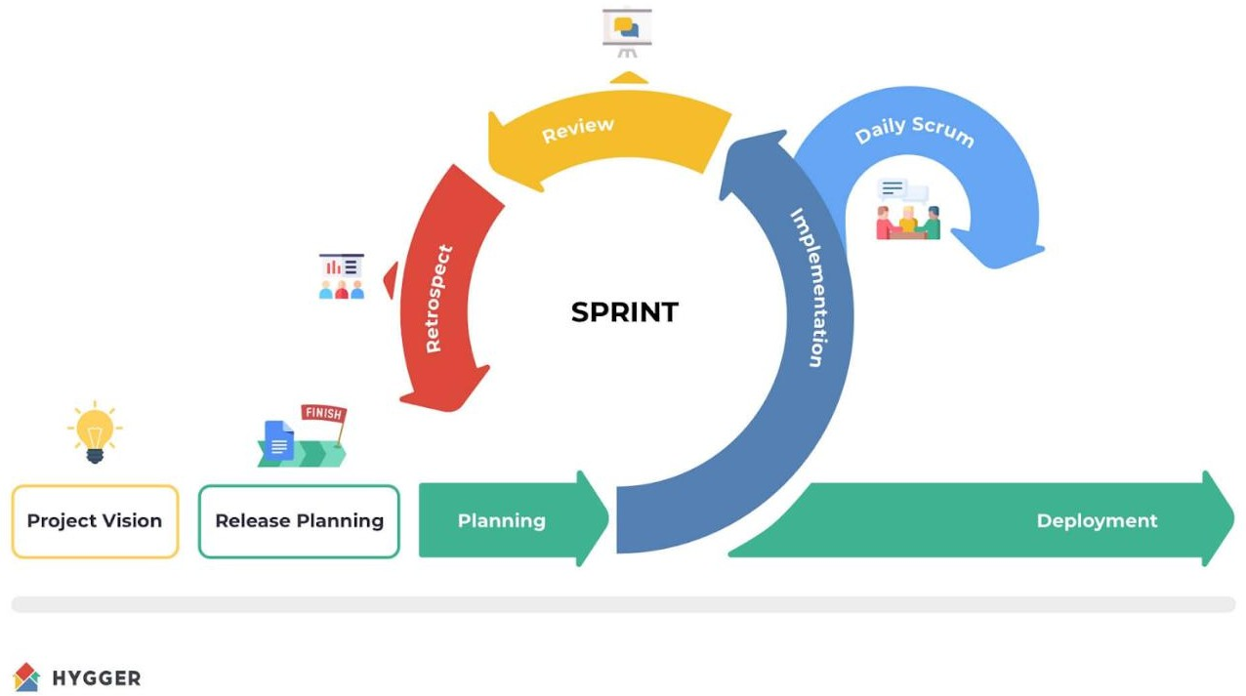

Figure 3.1 Scrum Methodology

Scrum Phases

Initiation (Project Vision & Release Planning). In this initial stage, the development team established the vision and clear objectives of the HealthBase system tailored specifically to Dr. Leelin Medical Clinic. The team began by identifying critical clinic processes and challenges through observations, discussions, and structured interviews with clinic staff, doctors, and administrative personnel. Through these activities, key features were identified, including patient registration management, intelligent appointment scheduling, predictive analytics for return-visit risks, and automated medical calculations. The gathered information was compiled into a prioritized list known as the product backlog, serving as a foundation for the subsequent phases of development.

Planning. In the planning phase, the overall vision for HealthBase was divided into manageable and achievable tasks scheduled into two-week development cycles known as "sprints." Each sprint had specific goals and deliverables, prioritized based on their impact on clinic efficiency and patient care. Initial sprints targeted the core functionalities, such as patient information management and smart scheduling, while later sprints addressed more advanced features like predictive analytics and user-interface refinements. Throughout this stage, the team also developed detailed system documentation, wireframes, and diagrams to ensure clear communication and alignment of the design with clinic requirements.
Implementation. The implementation phase involved active development of the HealthBase system according to the defined objectives. Team members took responsibility for specific system components, such as patient data modules, predictive analytics tools, scheduling algorithms, and user-friendly interfaces. Regular daily meetings ("daily scrums") facilitated close collaboration, allowing the team to promptly address challenges, track progress, and ensure tasks were completed within each sprint. Continuous testing during this phase confirmed the reliability and functionality of each system feature before moving forward to the next development stage.
Daily Scrum. Throughout each sprint, daily scrum meetings served as quick, focused discussions among the development team to review daily progress, share updates, identify immediate concerns, and realign tasks when necessary. These brief meetings ensured smooth coordination, clear communication, and

rapid problem resolution, maintaining steady progress aligned with project goals and clinic expectations.
Review. At the conclusion of every two-week sprint, completed features were presented to clinic stakeholders, including doctors, healthcare professionals, and administrative staff. These review sessions allowed the team to demonstrate the developed system functionalities, gather valuable feedback, and identify necessary improvements. Stakeholder suggestions were then documented and integrated into subsequent sprints, ensuring that HealthBase continued to evolve in alignment with the real-world needs of Dr. Leelin Medical Clinic.
Retrospective. Following each sprint review, a retrospective meeting was conducted for the development team to reflect on their collaboration, progress, and challenges encountered. During these discussions, the team evaluated what worked well, identified areas needing improvement, and defined strategies for enhancing efficiency and effectiveness in future sprints. Issues identified during retrospectives, such as unclear user requirements or technical misunderstandings, were promptly addressed to improve subsequent development cycles.
Deployment. The deployment phase marked the completion of HealthBase's development and its transition into everyday clinical operations at Dr. Leelin Medical Clinic. In this phase, the system was officially launched and made accessible to clinic staff and healthcare professionals. Final system testing was performed to verify usability, stability, and overall reliability. Upon deployment, clinic staff could start actively using HealthBase for patient management, scheduling, and clinical decision-making. Beyond initial deployment, the project

team remained actively engaged, providing ongoing support, gathering user feedback, and making continuous enhancements to ensure HealthBase consistently met the evolving needs of the clinic and effectively supported high- quality patient care.

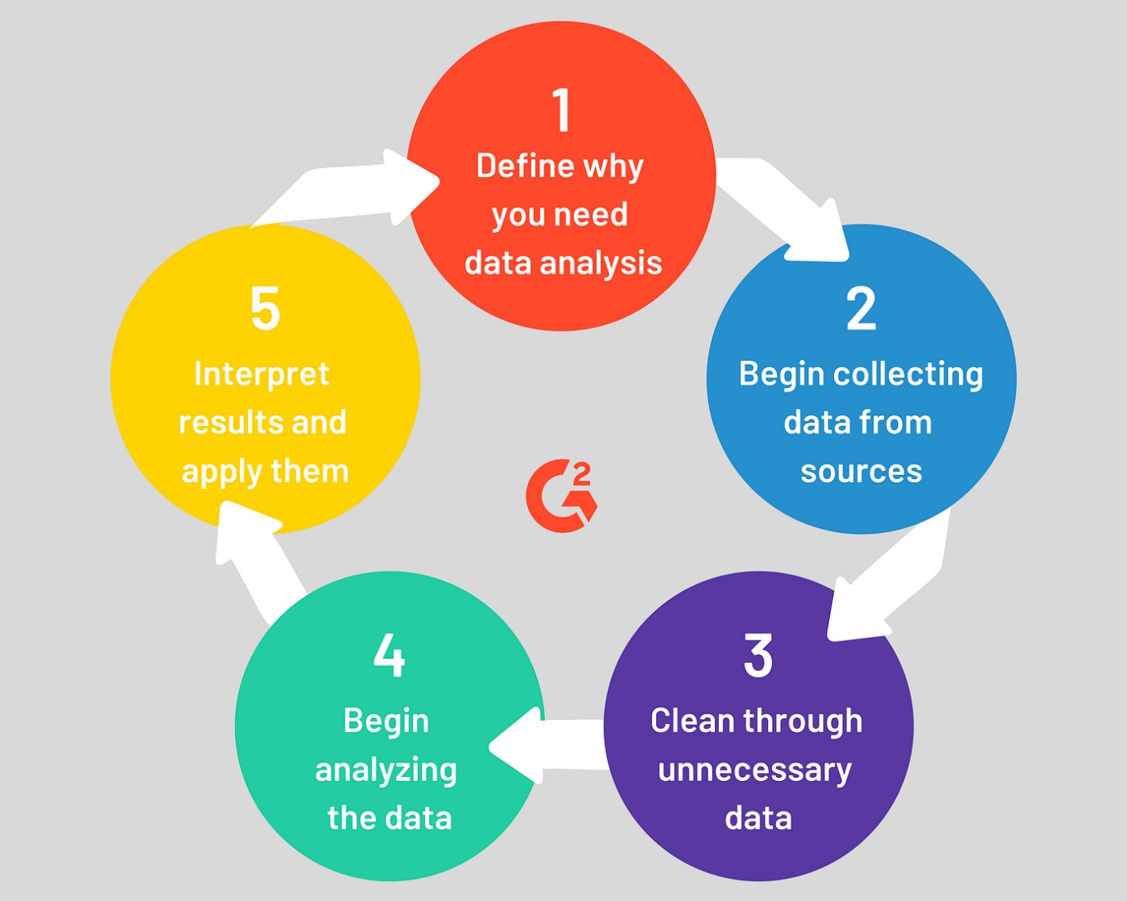
Figure 3.2 Data Analysis Process

Data analysis in this study follows a structured and systematic approach to gathering, organizing, and interpreting clinic-related data. The aim is to generate useful insights that support informed decisions and improvements within Dr. Leelin Medical Clinic. Two main data analysis techniques were used in developing the HealthBase system: descriptive analytics and predictive analytics. Descriptive analytics provided insights into patient trends, scheduling efficiency, and frequently encountered medical conditions, while predictive analytics allowed the early identification of patients likely needing return visits.

Step 1: Define the Question. Initially, the research team identified clear objectives to guide the data analysis. These objectives were based on the clinic’s operational and clinical needs, such as understanding patient scheduling patterns, identifying common reasons for patient visits, and determining factors associated with higher return visit risks.
Step 2: Collect the Data. Data was systematically collected from various sources within the clinic, including patient records, medical histories, appointment schedules, and clinical notes. Digital forms were utilized to ensure accurate, consistent data entry. Historical patient records were also reviewed, with appropriate permission, to support predictive analysis.
Step 3: Clean the Data. The collected data was carefully reviewed to ensure accuracy and reliability. This step included removing duplicate entries, correcting errors, and addressing missing or incomplete data. Additionally, patient data was standardized, ensuring consistency inareas like medical conditions, age groupings, and clinic visit dates..
Step 4: Analyze the Data. Once cleaned, the data was analyzed using descriptive and predictive techniques. Descriptive analytics helped identify patterns in patient demographics, common diagnoses, and clinic workloads, allowing the research team to understand existing clinic workflows clearly. Predictive analytics applied machine learning algorithms, such as Random Forest, to identify risk factors like patient age, medical history, and frequency of previous visits that predicted the likelihood of future clinic visits. This enabled the clinic staff to proactively address patient care needs.

Step 5: Visualization. Finally, findings from the data analysis were presented visually using clear and easy-to-understand tools such as charts, graphs, and dashboards. These visualizations made it simple to spot trends and identify areas requiring attention. A dedicated risk prediction dashboard, featuring clear indicators for patients at higher risk of return visits, allowed healthcare providers to make informed, timely decisions. Visualization tools thus played a significant role in enhancing patient management and optimizing clinic resources effectively at Dr. Leelin Medical Clinic.

Data-Flow Diagram Context Level Diagram
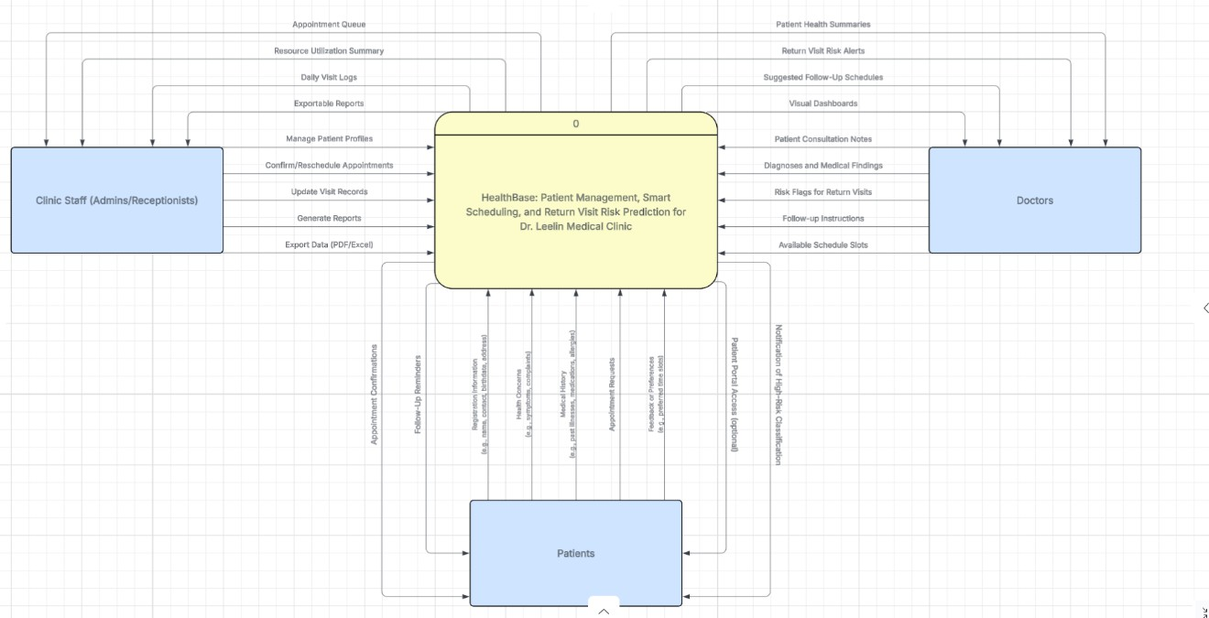
Figure 3.3 Context-Level Diagram of the Proposed System

This context-level diagram shows how the proposed system, HealthBase: Patient Management, Smart Scheduling, and Return Visit Risk Prediction for Dr. Leelin Medical Clinic, connects and interacts with its main users. It illustrates how the different groups within the clinic staff, doctors, and patients work together

through the system. At the center is HealthBase, which serves as the digital link between the administrative staff, healthcare providers, and patients. Clinic staff, such as admins and receptionists, use the system to manage patient profiles, handle appointment queues, update visit records, confirm or reschedule appointments, and generate reports to support clinic operations. Doctors interact with the system by accessing patient health summaries, reviewing consultation notes, viewing diagnoses and medical findings, and receiving suggested follow-up schedules and risk alerts for potential return visits. This helps them make more informed clinical decisions and better manage their daily schedules. Patients contribute to the system by providing registration details, health concerns, medical histories, and appointment requests. They also receive follow-up reminders, optional notifications if they are classified as high-risk, and (if available) access to a patient portal where they can stay updated on their care. Overall, HealthBase serves as a central platform that improves patient management, enhances scheduling, and supports proactive care through risk prediction. It helps streamline clinic workflows, improves coordination between staff and doctors, and keeps patients engaged in their own healthcare journey, ensuring that the clinic runs smoothly and patient care remains the top priority.

Top-Level Diagram

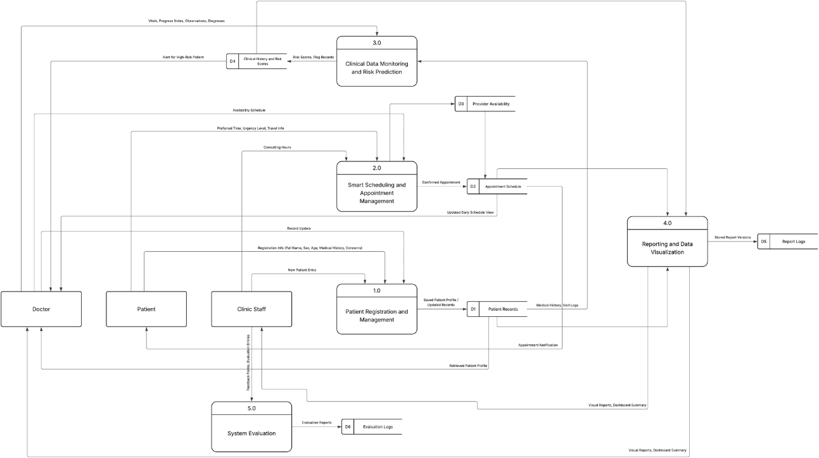

Figure 3.3 Top-Level Diagram of the Proposed System

This diagram illustrates the main functional modules and data flow within the HealthBase system for Dr. Leelin Medical Clinic, showing how patients, doctors, and clinic staff interact with the system to manage clinical information, appointments, risk assessments, and reporting. Patients provide key details during registration, such as full name, sex, age, medical history, and specific health concerns, which are entered by clinic staff into the Patient Registration and Management module. This module manages patient profiles, saves new records, and updates existing ones, ensuring accurate and up-to-date patient information. Clinic Staff handle patient intake, appointment bookings, and record updates through the Smart Scheduling and Appointment Management module. This module factors in doctor availability, consulting hours, urgency levels, and patient

preferences to generate an optimized appointment schedule. Staff also use the system to send appointment confirmations and notifications to patients. Doctors access Clinical Data Monitoring and Risk Prediction, where they review patient vitals, progress notes, medical history, and risk scores generated by the system. This helps them identify high-risk patients early and make informed clinical decisions. The system flags patients requiring closer follow-up and provides insights to support proactive care.The Reporting and Data Visualization module gathers medical histories, visit logs, and system activities to generate visual reports and dashboard summaries. These tools help both doctors and clinic staff monitor clinic operations, track patient trends, and identify areas for improvement. Lastly, the System Evaluation module collects feedback, reviews, and status updates from users to assess the system’s effectiveness. Evaluation logs and reports help the clinic understand how well HealthBase is performing, ensuring continuous improvement and alignment with clinic needs. Overall, this diagram highlights how HealthBase integrates patient management, scheduling, risk prediction, and reporting into a connected and efficient system, supporting better care delivery, smoother clinic workflows, and data-informed decision-making at Dr. Leelin Medical Clinic

Child Diagram

The Child Diagram provides a more granular view of the system’s internal operations, breaking down the core functions outlined in the Top-Level Diagram. It details the workflows for processes 1, 2, 3, 5, 6, 7, and 8, which are vital to the overall performance and functionality of the HealthBase system.
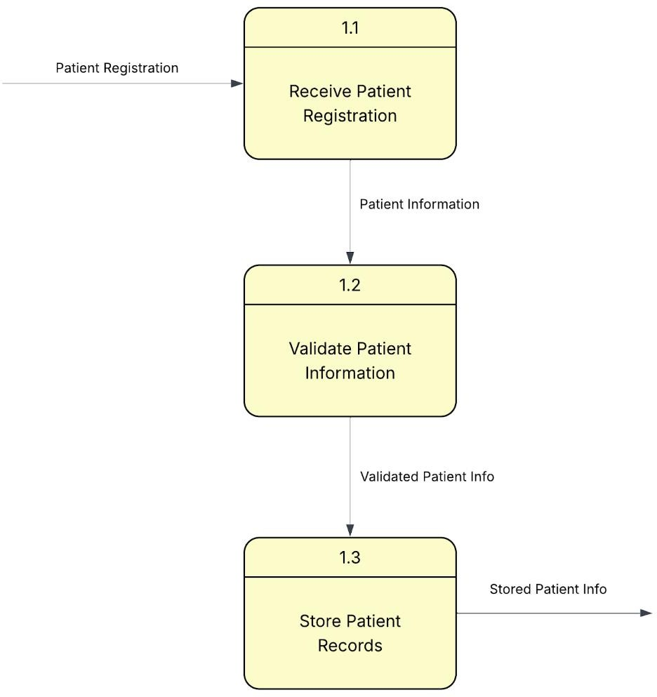

Figure 3.5. Child Diagram of Add and Manage Patient Records of the Proposed System

This module begins with receiving patient registration, where basic patient details are submitted. The information is then validated for completeness and accuracy. Once verified, the system proceeds to store the patient records in the central database.
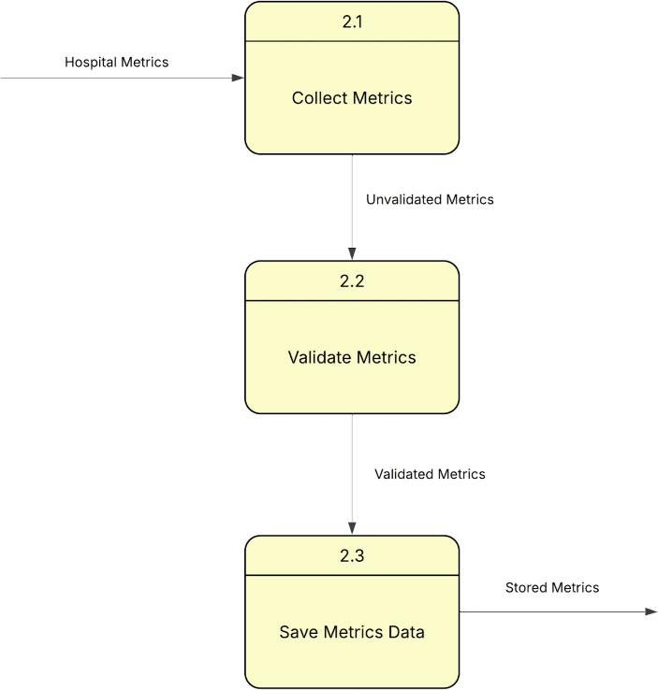

Figure 3.6. Child Diagram of Manage Clinic Metrics of the Proposed System

The process starts with collecting Clinic metrics from internal systems. These metrics are then validated to ensure reliability. Validated metrics are saved in the hospital’s metrics data store for analysis and institutional reporting.

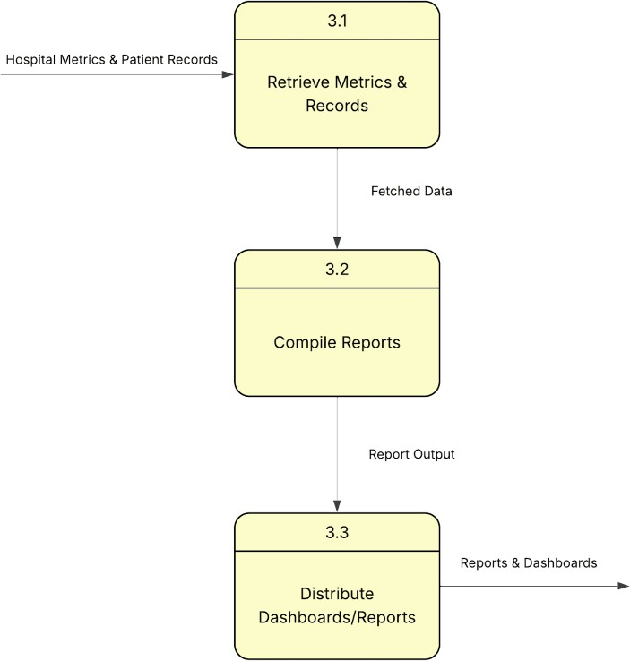

Figure 3.7. Child Diagram of Generate Reports and Dashboards of the Proposed System
This process retrieves necessary data, including patient records and Clinic metrics. The data is compiled into structured reports, which are then distributed as dashboards or summary documents for use by administrative and clinical staff.

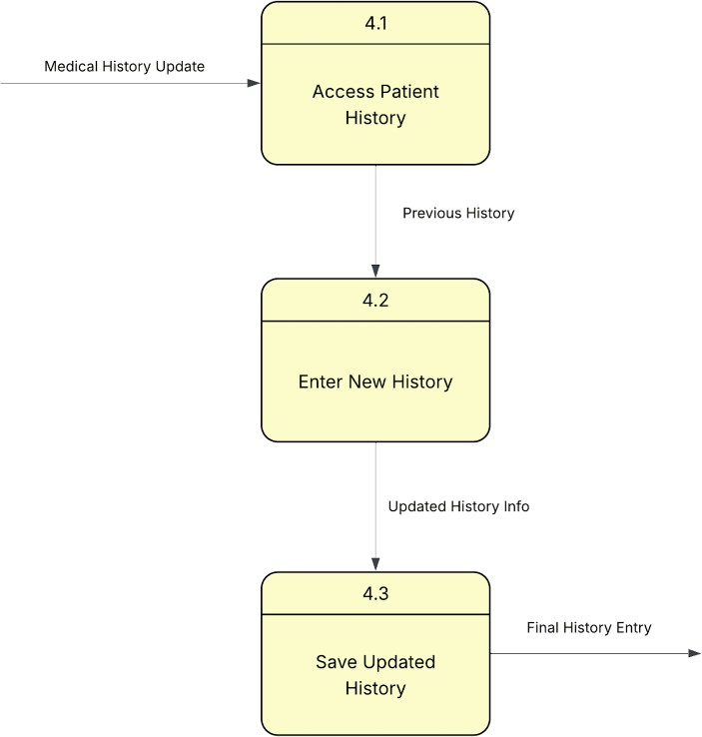

Figure 3.8. Child Diagram of Update Medical History of the Proposed System

Medical history updates start by accessing the patient's existing history. New information is entered by healthcare providers and then saved into the system to maintain a comprehensive and updated medical profile.

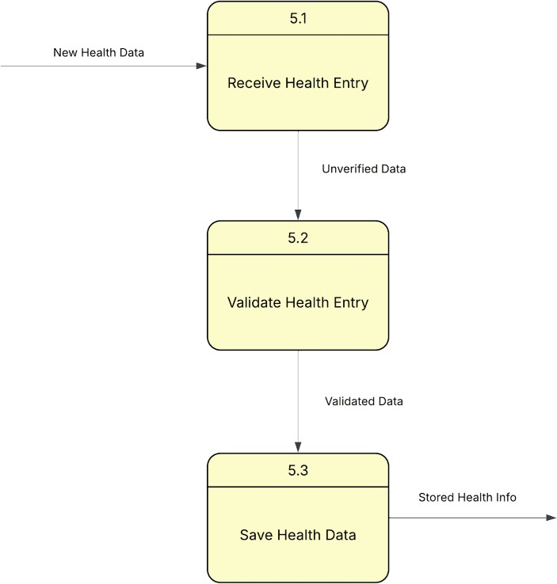

Figure 3.9. Child Diagram of Update Health Data of the Proposed System

The system first receives new health data entries, such as vitals or test results. These are validated for consistency and accuracy. Once confirmed, the health data is saved into the patient’s record to reflect their current clinical status.

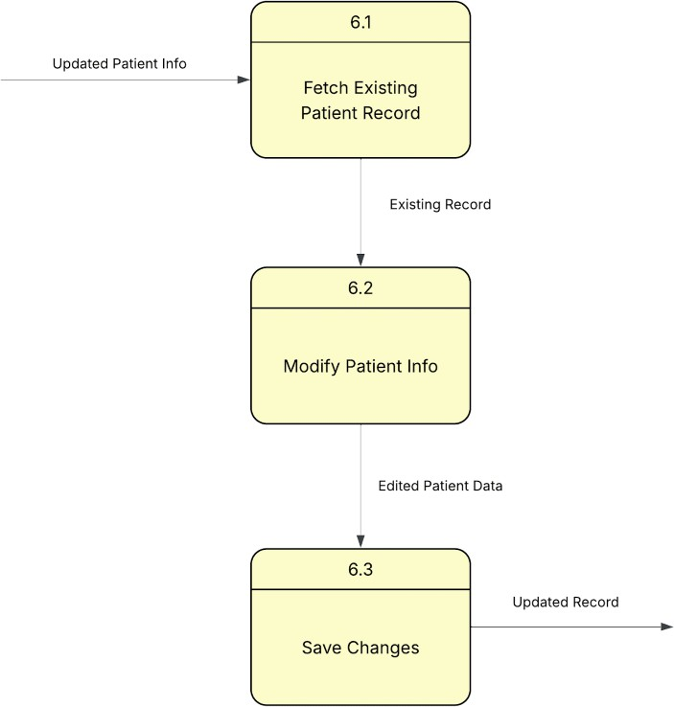

Figure 3.10. Child Diagram of Update Patient Records of the Proposed System

This module begins by fetching existing patient data. Authorized users modify or edit the patient’s information, and then save the updated record to ensure the profile reflects the latest details.

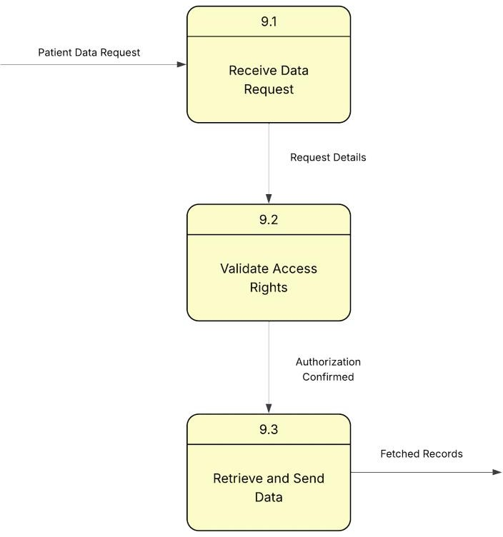

Figure 3.11. Child Diagram of Patient Data Requests of the Proposed System

The process begins when a patient data request is received. The system then validates access rights to confirm authorization. Once access is granted, the system retrieves and sends the requested data while ensuring compliance with data privacy standards.

Entity Relationship Diagram
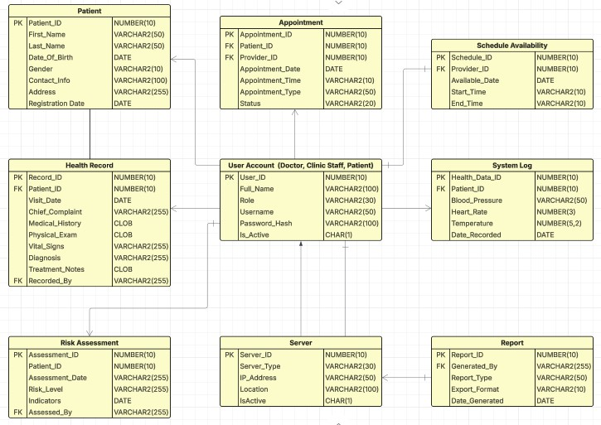

Figure 3.12. Entity Relationship Diagram (ERD) of the Proposed System

The Entity Relationship Diagram (ERD) illustrates how data is structured and connected within the HealthBase system for Dr. Leelin Medical Clinic. At the center is the Patient table, which stores essential patient details, including name, date of birth, contact information, and registration date. This table serves as the foundation, linking to several other key tables using the Patient_ID to ensure consistency across records. The Health Record table holds clinical information such as visit dates, chief complaints, medical history, physical examination details, vital signs, diagnoses, and treatment notes. This table connects directly to the Patient table, allowing the system to track each patient’s medical journey accurately. The Appointment table manages scheduling information, including

appointment dates, times, types, assigned providers, and appointment status. It links patients and providers to maintain an organized appointment system. Supporting this is the Schedule Availability table, which tracks the available dates and times for each provider. The User Account table manages accounts for all system users, including doctors, clinic staff, and patients. It records details like full name, role, username, and account status, ensuring controlled access across the system.The System Log table records key health data such as blood pressure, heart rate, and temperature, with time-stamped entries linked to each patient. This allows for continuous monitoring of basic health indicators.The Risk Assessment table tracks patient-specific risk evaluations, including assessment dates, risk levels, and indicators, helping clinicians identify patients who may need closer follow-up. The Server table maintains information about the servers running HealthBase, storing details like server type, IP address, and location, supporting system maintenance and stability. Lastly, the Report table handles the generation of various reports, including who generated them, the type of report, format, and generation date, providing clinic staff and doctors with summarized insights for informed decision-making. Overall, the ERD shows how HealthBase integrates patient care, scheduling, clinical documentation, and system operations into a connected, well-organized digital ecosystem, ensuring data consistency, security, and usability across the clinic.

System Architecture

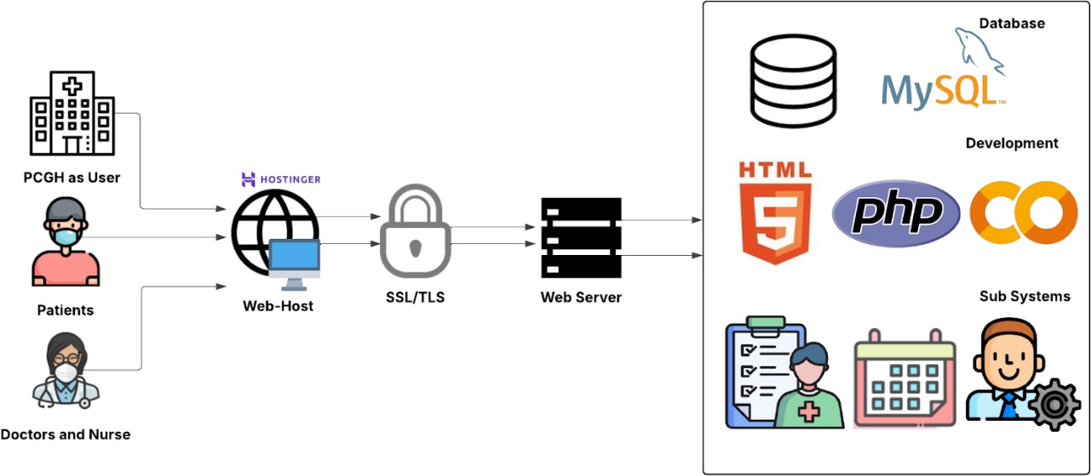

Figure 3.13. System Architecture of the Proposed System

The system architecture shows how HealthBase connects Dr. Leelin Medical Clinic’s staff, doctors, and patients through a secure online platform hosted by Hostinger. All data is protected using SSL/TLS encryption to maintain privacy and security. When users interact with the system, their requests are handled by the web server, which runs the main system functions and manages communication with the database.
The system is developed using HTML for the user interface, PHP for backend operations, and CodeIgniter to help organize and simplify the development process. All data, including patient records, health updates, and reports, is stored in a MySQL database, ensuring safe and well-structured data management.

For its prediction feature, the system uses Python in Google Colab to run a machine learning model that identifies patients who may be at risk of needing return visits. This supports improved monitoring and decision-making for the clinic’s healthcare providers. Dr. Leelin Medical Clinic serves as the system administrator, with full access to all modules. Doctors can update patient details and manage health records, while patients can register, edit their personal information, and request access to their data through their own devices. All information is securely stored and can only be accessed according to each user’s designated role in the system.
.

Use-Case Diagram
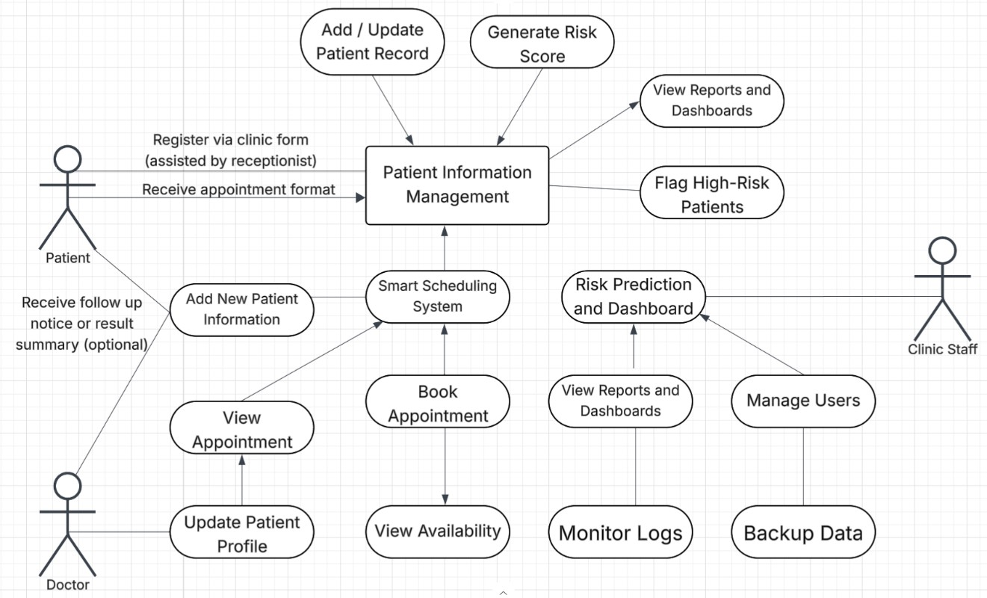
Figure 3.14 Use-Case Diagram of the Proposed System

This diagram illustrates the main functions and user interactions within the HealthBase system at Dr. Leelin Medical Clinic. It shows what each user group patients, doctors, and clinic staff can do inside the system, helping to clarify roles and responsibilities. Patients can register with the help of the receptionist, view their appointments, update their personal details, and optionally receive follow-up notices or result summaries. This makes it easier for patients to stay engaged in their own care, giving them more visibility and control over their health information. Doctors have access to key medical functions such as adding and updating patient records, reviewing appointments, and updating patient profiles with the latest medical findings. They can also check risk assessments and view generated reports, allowing them to provide timely and accurate care without relying on

manual paperwork. Clinic staff (such as receptionists or admin personnel) manage the overall flow of patient information. They handle tasks like adding new patient details, booking appointments through the smart scheduling system, confirming availability, managing user accounts, and monitoring system activity. They also access risk prediction dashboards, generate reports, and back up data, ensuring clinic operations run smoothly and securely. The system itself integrates all these activities through key modules: patient information management, smart scheduling, and risk prediction dashboards.
These modules allow the system to generate risk scores, flag high-risk patients, and present information through clear reports and dashboards. Some functions, like generating reports, are accessible to multiple user roles to ensure teamwork and information sharing. Overall, this diagram highlights how HealthBase brings together patients, doctors, and clinic staff in an organized and secure system, improving care delivery, simplifying processes, and supporting better clinic management.

Research Locale

This study has been conducted at Dr. Leelin Medical Clinic, a private outpatient clinic located in Makati City, Metro Manila, Philippines. The clinic serves a diverse range of patients, offering specialized services in Gastroenterology, Dermatology, and Orthopedics. With a dedicated but small team of doctors and administrative staff, the clinic provides daily consultations, diagnostic procedures, and follow-up care to both new and returning patients.

Dr. Leelin Medical Clinic has been identified as an ideal setting for implementing the HealthBase system due to its growing need for more efficient patient data management, smart scheduling, and proactive patient monitoring. While the clinic has already adopted certain digital tools, such as SIRIUSMD, there are still gaps in areas like predictive analytics for return visit risks and streamlined scheduling. These conditions make the clinic a suitable research site for testing the effectiveness of HealthBase as a tailored system designed to improve outpatient workflows, enhance the quality of care, and support clinic operations through well-organized data management and insightful reporting tools.

Sources of Data

The primary sources of data for this study will be gathered from the doctors, clinic staff, and administrative personnel of Dr. Leelin Medical Clinic. This includes the Gastroenterologist, Dermatologist-Orthopedic specialist, receptionists, and clinic assistants who are directly involved in patient care, appointment management, and record-keeping. Data will be collected through surveys, interviews, and observations to better understand the clinic’s current workflows, challenges in managing patient information, and user needs for an enhanced clinical information system.
Secondary data will come from existing clinic records, such as non- confidential patient profiles, appointment logs, consultation notes, and administrative reports. These documents will provide additional context on how the

clinic currently records, processes, and stores information, helping to inform the design and development of the proposed HealthBase system.

Data Collection

Interview. The researchers will conduct interviews with key personnel at Dr. Leelin Medical Clinic, including doctors, administrative staff, and receptionists, to gather insights on the current clinic workflow, challenges in patient data management, and their expectations for system improvements. These semi- structured interviews will help identify problem areas in processes such as patient registration, medical record handling, appointment scheduling, and follow-up tracking, guiding the design of the HealthBase system.
Observation. The researchers will also observe the clinic’s day-to-day operations, focusing on how staff handle patient intake, update medical records, manage appointments, and coordinate follow-up care. By directly observing these processes, the researchers can pinpoint workflow inefficiencies, repetitive tasks, or delays that can be addressed through system automation and better information management.
Survey Questionnaire. To gather user feedback and perspectives, the researchers will prepare and distribute survey questionnaires to clinic staff and doctors. These surveys will collect information about their experiences with current procedures, their expectations for the new system, and their evaluation of HealthBase in terms of usability, functionality, and efficiency, particularly during the system’s pilot testing phase.

System Performance Logs. The researchers will collect system performance data by tracking metrics from both the current processes and the implemented HealthBase system. This includes measuring processing times, error rates, system responsiveness, and reliability. This quantitative data will allow the researchers to compare the clinic’s operations before and after HealthBase implementation, providing clear evidence of improvements or areas needing adjustment.
Instruments. This study will use four main research instruments to collect well-rounded data for the development and evaluation of the HealthBase system. A semi-structured interview guide will gather qualitative insights from clinic personnel about workflow challenges, needs, and expectations for digital improvements. An observation checklist will help document how patient registration, record updates, appointment scheduling, and follow-ups are currently handled in the clinic. Pre- and post-implementation survey questionnaires will be used to assess users’ knowledge, expectations, and satisfaction with the system, using a modified 4-point Likert scale (1: Strongly Disagree; 2: Disagree; 3: Agree; 4: Strongly Agree).
Additionally, a custom system performance monitoring tool will track quantitative metrics such as processing times, error rates, and system reliability before and after implementation. These combined instruments will support statistical analyses, such as frequency and percentage distributions for demographic and process-related data, arithmetic means for assessing system improvements, and usability scores from the modified survey tool to evaluate the

overall impact of HealthBase. Together, these instruments will ensure a thorough evaluation covering technical, operational, and user experience aspects throughout the system’s development and deployment.

References

- S. J. Patel et al., "The evolution of health information systems: A review,"

Health Informatics Journal, vol. 25, no. 3, pp. 555–569, 2019.

- S. Dash, S. K. Shakyawar, M. Sharma, and S. Kaushik, "Big data in healthcare: Management, analysis and future prospects," Journal of Big Data, vol. 6, p. 54, 2019. [Online]. Available: https://doi.org/10.1186/s40537-019-0217-0
- E. Rojas, J. Munoz-Gama, M. Sepúlveda, and D. Capurro, "Process mining in healthcare: A literature review," Journal of Biomedical Informatics, vol. 61, pp. 224–236, 2016. [Online]. Available: https://doi.org/10.1016/j.jbi.2016.04.007
- H. Goldstein et al., "The implementation of healthcare IT in resource-limited settings," Healthcare Technology Letters, vol. 4, no. 4, pp. 109–114, 2017.
- E. J. Campbell et al., "Clinical decision support systems for medication safety: A systematic review," BMJ Quality & Safety, vol. 28, no. 7, pp. 561– 570, 2019.
- R. Aronson, "Medication errors: What they are, how they happen, and how to avoid them," QJM: An International Journal of Medicine, vol. 102, no. 8,
pp. 513–521, 2009.

- H. Chen et al., "Database management in healthcare: Design and implementation," Journal of Medical Systems, vol. 38, 2014.
- Y. Zhang et al., "Big data analytics in healthcare: Promise and potential,"

Health Information Science and Systems, vol. 6, no. 1, 2018.

- T. Benson and G. Grieve, Principles of Health Interoperability: SNOMED CT, HL7 and FHIR, 3rd ed., Springer, 2016.
- J. Mandl and I. S. Kohane, "Time for a patient-driven health information economy?" New England Journal of Medicine, vol. 374, pp. 205–208, 2016.
- J. Futoma et al., "An improved multi-output Gaussian process RNN with real-time validation for early sepsis detection," in Machine Learning for Healthcare Conference, 2017.
- Rajkomar et al., "Scalable and accurate deep learning for electronic health records," npj Digital Medicine, vol. 1, no. 1, 2018.
- L. Holmgren et al., "Hospital readmission risk prediction using EHR data: A systematic review," Journal of the American Medical Informatics Association, vol. 27, no. 5, pp. 782–795, 2020.
- K. Ndlovu, M. Mars, and R. E. Scott, "Interoperability frameworks linking mHealth applications to electronic record systems," BMC Health Services Research, vol. 21, p. 459, 2021. [Online]. Available: https://doi.org/10.1186/s12913-021-06473-6
- M. Wornow, Y. Xu, R. Thapa et al., "The shaky foundations of large language models and foundation models for electronic health records," npj Digital Medicine, vol. 6, p. 135, 2023. [Online]. Available: https://doi.org/10.1038/s41746-023-00879-8
- M. Tayefi et al., "Challenges and opportunities beyond structured data in analysis of electronic health records," WIREs Computational

Statistics, vol. 13, 2021. [Online]. Available: https://doi.org/10.1002/wics.1549
- Tapuria et al., "Impact of patient access to their electronic health record: Systematic review," Informatics for Health and Social Care, vol. 46, no. 2, pp. 192–204, 2021. [Online]. Available: https://doi.org/10.1080/17538157.2021.1879810
- L. Cook et al., "Issues with variability in electronic health record data about race and ethnicity," JMIR Medical Informatics, vol. 10, no. 9, e39235, 2022. [Online]. Available: https://doi.org/10.2196/39235
- M. J. Sembay et al., "Provenance data management in health information systems: A systematic literature review," Journal of Personalized Medicine, vol. 13, no. 6, p. 991, 2023. [Online]. Available: https://doi.org/10.3390/jpm13060991
- E. Mbunge et al., "Sensors and healthcare 5.0: Transformative shift in virtual care through emerging digital health technologies," Global Health Journal, vol. 5, no. 4, pp. 169–177, 2021. [Online]. Available: https://doi.org/10.1016/j.glohj.2021.11.008
- G. Bologa et al., "High performance implementation of the hierarchical likelihood for generalized linear mixed models," BMC Medical Research Methodology, vol. 21, p. 151, 2021. [Online]. Available: https://doi.org/10.1186/s12874-021-01318-6
- J. E. Linder et al., "The role of electronic health records in advancing genomic medicine," Annual Review of Genomics and Human Genetics, vol.

22, pp. 1–23, 2021. [Online]. Available: https://doi.org/10.1146/annurev-

genom-121120-125204

- J. S. Marwaha et al., "Deploying digital health tools within large, complex health systems: Key considerations for adoption and implementation," npj Digital Medicine, vol. 5, Art. no. 13, 2022. [Online]. Available: https://doi.org/10.1038/s41746-022-00557-1
- O. Ozonze, P. J. Scott, and A. A. Hopgood, "Automating electronic health record data quality assessment," Journal of Medical Systems, vol. 47, p. 23, 2023. [Online]. Available: https://doi.org/10.1007/s10916-022-
01892-2

- G. Patra et al., "Extracting social determinants of health from electronic health records using natural language processing: A systematic review," Journal of the American Medical Informatics Association, vol. 28, no. 12, pp. 2716–2727, 2021. [Online]. Available: https://doi.org/10.1093/jamia/ocab170
- S. Whitelaw et al., "Barriers and facilitators of the uptake of digital health technology in cardiovascular care: A systematic scoping review," European Heart Journal – Digital Health, vol. 2, no. 1, pp. 62–74, 2021. [Online]. Available: https://doi.org/10.1093/ehjdh/ztab005
- Li et al., "The impact of electronic health record interoperability on safety and quality of care in high-income countries: Systematic review," Journal of Medical Internet Research, vol. 24, no. 9, e38144, 2022. [Online]. Available: https://doi.org/10.2196/38144

- S. Syed et al., "Predictive value of indicators for identifying child maltreatment and intimate partner violence in coded electronic health records," Archives of Disease in Childhood, vol. 106, no. 1, pp. 44–53, 2021. [Online]. Available: https://doi.org/10.1136/archdischild-2020-319027
- R. Y. H. De Mesa et al., "Facing the digital frontier: Exploring user acceptance of electronic health records in the Philippines," BMJ Open Quality, vol. 13, no. 2, e002621, 2024. [Online]. Available: https://doi.org/10.1136/bmjoq-2023-002621
- Manteghinejad and S. H. Javanmard, "Challenges and opportunities of digital health in a post-COVID-19 world," Journal of Research in Medical Sciences, vol. 26, p. 11, 2021. [Online]. Available: https://doi.org/10.4103/jrms.JRMS_1255_20
- P. J. Acacio-Claro et al., "Understanding adoption of electronic medical records (EMRs) during a health emergency," Acta Medica Philippina, vol. 58, no. 22, 2024. [Online]. Available: https://doi.org/10.47895/amp.vi0.8911
- S. Kumar et al., "Blockchain in healthcare: Investigating the applications of blockchain technology in securing electronic health records," Cuestiones de Fisioterapia, vol. 53, no. 3, pp. 429–456, 2024. [Online]. Available: https://doi.org/10.48047/ye0wf646
- C. D. Padilla et al., "Integrating genetic services in the Philippine public health delivery system: The value of networks," Genes, vol. 15, no. 6, p. 780, 2024. [Online]. Available: https://doi.org/10.3390/genes15060780

- V. de Claro and A. de Claro, "Holes in the armor: Addressing the gaps in healthcare cybersecurity in the Philippines and beyond," Mayo Clinic Proceedings: Digital Health, vol. 2, no. 1, pp. 32–33, 2024. [Online]. Available: https://doi.org/10.1016/j.mcpdig.2023.11.007
- M. I. M. Salleh, R. Abdullah, and N. Zakaria, "Evaluating the effects of electronic health records system adoption on the performance of Malaysian healthcare providers," BMC Medical Informatics and Decision Making, vol. 21, Art. no. 75, 2021. [Online]. Available: https://doi.org/10.1186/s12911-021-01447-4
- A. Epizitone, S. P. Moyane, and I. E. Agbehadji, "A systematic literature review of health information systems for healthcare," Healthcare, vol. 11, no. 7, p. 959, 2023. [Online]. Available: https://doi.org/10.3390/healthcare11070959
- M. Shaikh, A. H. M. Vayani, S. Akram, and N. Qamar, "Open-source electronic health record systems: A systematic review of most recent advances," Health Informatics Journal, vol. 28, no. 2, 2022. [Online]. Available: https://doi.org/10.1177/14604582221099828
- H. Finnegan and N. Mountford, "25 years of electronic health record implementation processes: Scoping review," Journal of Medical Internet Research, vol. 27, e60077, 2025. [Online]. Available: https://doi.org/10.2196/60077
- E. Psarra, D. Apostolou, Y. Verginadis et al., "Permissioned blockchain network for proactive access control to electronic health

records," BMC Medical Informatics and Decision Making, vol. 24, p. 303, 2024. [Online]. Available: https://doi.org/10.1186/s12911-024-02708-8
- A. Mantri, V. Makutam, S. M. A. M. Javid et al., "An overview on clinical data management and role of Pharm.D in clinical data management," World Journal of Pharmaceutical and Medical Research, vol. 10, no. 8, pp. 299–303, 2023. [Online]. Available: https://www.researchgate.net/publication/383665730
- N. R. B. Rosales, "Nurses’ satisfaction with adopting a homegrown public tertiary hospital electronic medical record during the pandemic," Acta Medica Philippina, Advance online publication, 2024. [Online]. Available: https://doi.org/10.47895/amp.vi0.10687
- F. Xie, H. Yuan, Y. Ning et al., "Deep learning for temporal data representation in electronic health records: A systematic review of challenges and methodologies," Journal of Biomedical Informatics, vol. 126,
p. 103980, 2022. [Online]. Available: https://doi.org/10.1016/j.jbi.2021.103980
- F. Wurster, C. Herrmann, M. Beckmann et al., "Differences in changes of data completeness after the implementation of an electronic medical record in three surgical departments of a German hospital," BMC Medical Informatics and Decision Making, vol. 24, p. 258, 2024. [Online]. Available: https://doi.org/10.1186/s12911-024-02667-0
- N. N. Basil, S. Ambe, C. Ekhator, and E. Fonkem, "Health records database and inherent security concerns: A review of the literature,"

Cureus, vol. 14, no. 10, e30168, 2022. [Online]. Available: https://doi.org/10.7759/cureus.30168
- C. Yuvarajan, S. N. Priya, and A. Bhoomadevi, "Designing a mobile health platform for effective medical records management in hospitals," Scientific Set Journal of Pediatrics, vol. 2, no. 4, pp. 1–11, 2024. [Online]. Available: https://doi.org/10.1007/s42452-025-06777-w
- Y. K. C. Aban, J. V. Abunto, J. V. E. P. Aliorde et al., "The rise of telemedicine in the Philippines during COVID-19: A systematic review of utilization trends and patient outcomes," Philippine Social Science Journal, vol. 6, no. 4, pp. 9–18, 2024. [Online]. Available: https://doi.org/10.52006/main.v6i4.876
- R. M. Samaniego, "Mental health legislation in the Philippines: Its beginnings, highlights, and updates," Taiwanese Journal of Psychiatry, vol. 36, no. 2, pp. 51–58, 2022. [Online]. Available: https://doi.org/10.1016/j.dsx.2024.102951
- P. N. Ngugi, M. C. Were, and A. Babic, "Users’ perception on factors contributing to electronic medical records systems use: A focus group discussion study in healthcare facilities setting in Kenya," BMC Medical Informatics and Decision Making, vol. 21, Art. no. 362, 2021. [Online]. Available: https://doi.org/10.1186/s12911-021-01737-x
- S. Antonio, M. Dancel, M. C. Estioco, M. V. Abante, and F. Vigonte, "The impact of government economic policies in shaping hospital response

to public health crisis in the Philippines," SSRN, 2025. [Online]. Available: https://doi.org/10.2139/ssrn.5140387
- R. Naamneh and M. Bodas, "The effect of electronic medical records on medication errors, workload, and medical information availability among qualified nurses in Israel–a cross-sectional study," BMC Nursing, vol. 23, Art. no. 270, 2024. [Online]. Available: https://doi.org/10.1186/s12912-024-
01936-7

- L. F. T. Cando et al., "Current status of diabetes mellitus care and management in the Philippines," Diabetes & Metabolic Syndrome: Clinical Research & Reviews, vol. 18, no. 4, p. 103005, 2024. [Online]. Available: https://doi.org/10.1016/j.dsx.2024.102951
- J. E. Gerwer, G. Bacani, P. S. Juang, and K. Kulasa, "Electronic health record–based decision-making support in inpatient diabetes management," Current Diabetes Reports, vol. 22, no. 9, pp. 433–440, 2022. [Online]. Available: https://doi.org/10.1007/s11892-022-01481-0
- G. O. Anuran et al., "Telemedicine services in the University of the Philippines Health Service during the COVID-19 pandemic," Acta Medica Philippina, vol. 55, no. 2, 2021. [Online]. Available: https://doi.org/10.47895/amp.v55i2.2806
- T. J. Avelino-Silva and O. Jaluul, "Malnutrition in hospitalized old patients: Screening and diagnosis, clinical outcomes, and management," Nutrients, vol. 14, no. 4, p. 910, 2022. [Online]. Available: https://doi.org/10.3390/nu14040910

- J. Moy et al., "Measurement of clinical documentation burden among physicians and nurses using electronic health records: A scoping review," Journal of the American Medical Informatics Association, vol. 28, no. 5, pp. 998–1008, 2021. [Online]. Available: https://doi.org/10.1093/jamia/ocaa325
- R. Alibudbud, "Navigating the Philippine mental health system for the nation’s youth: Challenges and opportunities," BJPsych International, vol. 21, no. 3, pp. 56–58, 2024. [Online]. Available: https://doi.org/10.1192/bji.2024.5
- D. Harries et al., "Primary Health Care System Strengthening Project in Sri Lanka: Status and Challenges with Human Resources, Information Systems, Drugs and Laboratory Services," Healthcare, vol. 10, no. 11, p. 2251, 2022. [Online]. Available: https://doi.org/10.3390/healthcare10112251
- T. Henriksen et al., "Medication management for patients with hip fracture at a regional hospital and associated primary care units in Norway," BMJ Open, vol. 12, no. 11, e064868, 2022. [Online]. Available: https://doi.org/10.1136/bmjopen-2022-064868
- G. G. Dumancas et al., "Barriers and recommendations for establishing a COVID-19 patient registry in a regional setting in the
- S. J. Patel et al., "The evolution of health information systems: A review," Health Informatics Journal, vol. 25, no. 3, pp. 555–569, 2019.
- S. Dash, S. K. Shakyawar, M. Sharma, and S. Kaushik, "Big data in healthcare: Management, analysis and future prospects," Journal of Big

Data, vol. 6, p. 54, 2019. [Online]. Available: https://doi.org/10.1186/s40537-019-0217-0
- E. Rojas, J. Munoz-Gama, M. Sepúlveda, and D. Capurro, "Process mining in healthcare: A literature review," Journal of Biomedical Informatics, vol. 61, pp. 224–236, 2016. [Online]. Available: https://doi.org/10.1016/j.jbi.2016.04.007
- H. Goldstein et al., "The implementation of healthcare IT in resource- limited settings," Healthcare Technology Letters, vol. 4, no. 4, pp. 109–114, 2017.
- E. J. Campbell et al., "Clinical decision support systems for medication safety: A systematic review," BMJ Quality & Safety, vol. 28, no. 7, pp. 561–570, 2019.
- R. Aronson, "Medication errors: What they are, how they happen, and how to avoid them," QJM: An International Journal of Medicine, vol. 102, no. 8, pp. 513–521, 2009.
- H. Chen et al., "Database management in healthcare: Design and implementation," Journal of Medical Systems, vol. 38, 2014.
- Y. Zhang et al., "Big data analytics in healthcare: Promise and potential," Health Information Science and Systems, vol. 6, no. 1, 2018.
- T. Benson and G. Grieve, Principles of Health Interoperability: SNOMED CT, HL7 and FHIR, 3rd ed., Springer, 2016.

- J. Mandl and I. S. Kohane, "Time for a patient-driven health information economy?" New England Journal of Medicine, vol. 374, pp. 205–208, 2016.
- J. Futoma et al., "An improved multi-output Gaussian process RNN with real-time validation for early sepsis detection," in Machine Learning for Healthcare Conference, 2017.
- Rajkomar et al., "Scalable and accurate deep learning for electronic health records," npj Digital Medicine, vol. 1, no. 1, 2018.
- L. Holmgren et al., "Hospital readmission risk prediction using EHR data: A systematic review," Journal of the American Medical Informatics Association, vol. 27, no. 5, pp. 782–795, 2020.
- K. Ndlovu, M. Mars, and R. E. Scott, "Interoperability frameworks linking mHealth applications to electronic record systems," BMC Health Services Research, vol. 21, p. 459, 2021. [Online]. Available: https://doi.org/10.1186/s12913-021-06473-6
- M. Tayefi et al., "Challenges and opportunities beyond structured data in analysis of electronic health records," WIREs Computational Statistics, vol. 13, 2021. [Online]. Available: https://doi.org/10.1002/wics.1549
- Tapuria et al., "Impact of patient access to their electronic health record: Systematic review," Informatics for Health and Social Care, vol. 46, no. 2, pp. 192–204, 2021. [Online]. Available: https://doi.org/10.1080/17538157.2021.1879810

- J. S. Marwaha et al., "Deploying digital health tools within large, complex health systems: Key considerations for adoption and implementation," npj Digital Medicine, vol. 5, Art. no. 13, 2022. [Online]. Available: https://doi.org/10.1038/s41746-022-00557-1
- O. Ozonze, P. J. Scott, and A. A. Hopgood, "Automating electronic health record data quality assessment," Journal of Medical Systems, vol. 47, p. 23, 2023. [Online]. Available: https://doi.org/10.1007/s10916-022-
01892-2

- Li et al., "The impact of electronic health record interoperability on safety and quality of care in high-income countries: Systematic review," Journal of Medical Internet Research, vol. 24, no. 9, e38144, 2022. [Online]. Available: https://doi.org/10.2196/38144
- R. Y. H. De Mesa et al., "Facing the digital frontier: Exploring user acceptance of electronic health records in the Philippines," BMJ Open Quality, vol. 13, no. 2, e002621, 2024. [Online]. Available: https://doi.org/10.1136/bmjoq-2023-002621
- Manteghinejad and S. H. Javanmard, "Challenges and opportunities of digital health in a post-COVID-19 world," Journal of Research in Medical Sciences, vol. 26, p. 11, 2021. [Online]. Available: https://doi.org/10.4103/jrms.JRMS_1255_20
- P. J. Acacio-Claro et al., "Understanding adoption of electronic medical records (EMRs) during a health emergency," Acta Medica

Philippina, vol. 58, no. 22, 2024. [Online]. Available: https://doi.org/10.47895/amp.vi0.8911
- V. de Claro and A. de Claro, "Holes in the armor: Addressing the gaps in healthcare cybersecurity in the Philippines and beyond," Mayo Clinic Proceedings: Digital Health, vol. 2, no. 1, pp. 32–33, 2024. [Online]. Available: https://doi.org/10.1016/j.mcpdig.2023.11.007
- M. I. M. Salleh, R. Abdullah, and N. Zakaria, "Evaluating the effects of electronic health records system adoption on the performance of Malaysian healthcare providers," BMC Medical Informatics and Decision Making, vol. 21, Art. no. 75, 2021. [Online]. Available: https://doi.org/10.1186/s12911-021-01447-4
- A. Epizitone, S. P. Moyane, and I. E. Agbehadji, "A systematic literature review of health information systems for healthcare," Healthcare, vol. 11, no. 7, p. 959, 2023. [Online]. Available: https://doi.org/10.3390/healthcare11070959
- M. Shaikh, A. H. M. Vayani, S. Akram, and N. Qamar, "Open-source electronic health record systems: A systematic review of most recent advances," Health Informatics Journal, vol. 28, no. 2, 2022. [Online]. Available: https://doi.org/10.1177/14604582221099828
- H. Finnegan and N. Mountford, "25 years of electronic health record implementation processes: Scoping review," Journal of Medical Internet Research, vol. 27, e60077, 2025. [Online]. Available: https://doi.org/10.2196/60077

- N. R. B. Rosales, "Nurses’ satisfaction with adopting a homegrown public tertiary hospital electronic medical record during the pandemic," Acta Medica Philippina, Advance online publication, 2024. [Online]. Available: https://doi.org/10.47895/amp.vi0.10687
- F. Wurster, C. Herrmann, M. Beckmann et al., "Differences in changes of data completeness after the implementation of an electronic medical record in three surgical departments of a German hospital," BMC Medical Informatics and Decision Making, vol. 24, p. 258, 2024. [Online]. Available: https://doi.org/10.1186/s12911-024-02667-0
- N. N. Basil, S. Ambe, C. Ekhator, and E. Fonkem, "Health records database and inherent security concerns: A review of the literature," Cureus, vol. 14, no. 10, e30168, 2022. [Online]. Available: https://doi.org/10.7759/cureus.30168
- C. Yuvarajan, S. N. Priya, and A. Bhoomadevi, "Designing a mobile health platform for effective medical records management in hospitals," Scientific Set Journal of Pediatrics, vol. 2, no. 4, pp. 1–11, 2024. [Online]. Available: https://doi.org/10.1007/s42452-025-06777-w
- Y. K. C. Aban, J. V. Abunto, J. V. E. P. Aliorde et al., "The rise of telemedicine in the Philippines during COVID-19: A systematic review of utilization trends and patient outcomes," Philippine Social Science Journal, vol. 6, no. 4, pp. 9–18, 2024. [Online]. Available: https://doi.org/10.52006/main.v6i4.876

- P. N. Ngugi, M. C. Were, and A. Babic, "Users’ perception on factors contributing to electronic medical records systems use: A focus group discussion study in healthcare facilities setting in Kenya," BMC Medical Informatics and Decision Making, vol. 21, Art. no. 362, 2021. [Online]. Available: https://doi.org/10.1186/s12911-021-01737-x
- R. Naamneh and M. Bodas, "The effect of electronic medical records on medication errors, workload, and medical information availability among qualified nurses in Israel–a cross-sectional study," BMC Nursing, vol. 23, Art. no. 270, 2024. [Online]. Available: https://doi.org/10.1186/s12912-024-
01936-7

- G. O. Anuran et al., "Telemedicine services in the University of the Philippines Health Service during the COVID-19 pandemic," Acta Medica Philippina, vol. 55, no. 2, 2021. [Online]. Available: https://doi.org/10.47895/amp.v55i2.2806
- J. Moy et al., "Measurement of clinical documentation burden among physicians and nurses using electronic health records: A scoping review," Journal of the American Medical Informatics Association, vol. 28, no. 5, pp. 998–1008, 2021. [Online]. Available: https://doi.org/10.1093/jamia/ocaa325
- C. Li, C. Parpia, and A. Sriharan, "Burnout related to electronic health record use in primary care," Journal of Primary Care & Community Health, vol. 14, 21501319231166921, 2023. [Online]. Available: https://doi.org/10.1177/21501319231166921

- Windari, K. Kismartini, Y. Luqman, and B. Wijanarko, "Organizational effect on the implementation of “SIMRS” in hospitals: A systematic review," Journal of Health Policy and Management, vol. 8, no. 1, pp. 13–22, 2023. [Online]. Available: https://doi.org/10.26911/thejhpm.2023.08.01.02
- İ. Köse et al., "Basic electronic health record (EHR) adoption in Türkiye is nearly complete but challenges persist," BMC Health Services Research, vol. 23, p. 987, 2023. [Online]. Available: https://doi.org/10.1186/s12913-023-09859-w
- M. K. Hossain et al., "Electronic medical record implementation and recordkeeping culture," BMC Health Services Research, vol. 25, p. 249, 2025. [Online]. Available: https://doi.org/10.1186/s12913-025-12399-0
- E. Antor, J. Owusu-Marfo, and J. Kissi, "Usability evaluation of electronic health records," BMC Medical Informatics and Decision Making, vol. 24, p. 231, 2024. [Online]. Available: https://doi.org/10.1186/s12911-
024-02636-7

- J. E. M. Cortez et al., "Health information system users in public health facilities," International Journal of Multidisciplinary: Applied Business and Education Research, vol. 4, no. 1, pp. 156–173, 2023. [Online].
Available: https://doi.org/10.11594/ijmaber.04.01.15

- K. C. Derecho et al., "Technology adoption of electronic medical records in developing economies," Digital Health, vol. 9, Article 20552076231224605, 2024. [Online]. Available: https://doi.org/10.1177/20552076231224605

- Torab-Miandoab et al., "Interoperability of heterogeneous health information systems," BMC Medical Informatics and Decision Making, vol. 23, p. 18, 2023. [Online]. Available: https://doi.org/10.1186/s12911-023-
02115-5

- Kang and I. N. Sarkar, "Interventions to reduce electronic health record-related burnout: A systematic review," Applied Clinical Informatics, vol. 15, no. 1, pp. 10–25, 2024. [Online]. Available: https://doi.org/10.1055/a-2203-3787
- H. Maarsingh et al., "Implementing electronic health records on a medical service trip improves the patient care process," Frontiers in Health Services, vol. 2, p. 960427, 2022. [Online]. Available: https://doi.org/10.3389/frhs.2022.960427
- E. Lewis et al., "Electronic health record data quality assessment and tools: A systematic review," Journal of the American Medical Informatics Association, vol. 30, no. 10, pp. 1730–1740, 2023. [Online]. Available: https://doi.org/10.1093/jamia/ocad120
- L. S. Rotenstein, N. Hendrix, R. L. Phillips, J. Adler-Milstein, and R. Willard-Grace, "Team and electronic health record features and burnout among family physicians," JAMA Network Open, vol. 7, no. 11, e2442687, 2024. [Online]. Available: https://doi.org/10.1001/jamanetworkopen.2024.42687
- H. Tsai et al., "Effects of electronic health record implementation and barriers to adoption and use: A scoping review and qualitative analysis,"

Life, vol. 10, no. 12, p. 327, 2020. [Online]. Available: https://doi.org/10.3390/life10120327
- M. Alharthi, F. Alotaibi, A. Alzahrani, and S. Alghamdi, "An examination of large-scale electronic health records implementation in primary healthcare centers in Saudi Arabia," Frontiers in Public Health, vol. 11, p. 1121327, 2023. [Online]. Available: https://doi.org/10.3389/fpubh.2023.1121327
- D. Helminski et al., "Dashboards in health care settings: Protocol for a scoping review," JMIR Research Protocols, vol. 11, no. 3, e34894, 2022. [Online]. Available: https://doi.org/10.2196/34894
- D. F. Sittig, P. Lakhani, and H. Singh, "Applying requisite imagination to safeguard electronic health record transitions," Journal of the American Medical Informatics Association, vol. 29, no. 5, pp. 1014–1018, 2022. [Online]. Available: https://doi.org/10.1093/jamia/ocab291
- Y. Shen, J. Yu, J. Zhou, and G. Hu, "Twenty-five years of evolution and hurdles in electronic health records and interoperability in medical research: Comprehensive review," Journal of Medical Internet Research, vol. 27, e59024, 2025. [Online]. Available: https://doi.org/10.2196/59024
- H. S. F. Fraser, M. Mugisha, I. Bacher, J. L. Ngenzi, C. Seebregts,

A. Umubyeyi, and J. Condo, "Factors influencing data quality in electronic health record systems in 50 health facilities in Rwanda and the role of clinical alerts: Cross-sectional observational study," JMIR Public Health and

Surveillance, vol. 10, e49127, 2024. [Online]. Available: https://doi.org/10.2196/49127

